

**Kubernetes Installation and Configuration with multi-node cluster using containerd**

**Version History**

|  |  |  |  |  |  |
| --- | --- | --- | --- | --- | --- |
| SI | Date | Ver | Description | Changed by | Approved/Reviewed by |
| 01 | 02-Oct-21 | 1.0 | Kubernetes Installation and Configuration with multi-node cluster using containerd | Maidul Islam  Software Engineer | Md. Mahedee Hasan  Head of Software Development |

Contents

Introduction 2

Installation Requirements 2

Cluster Network Ports 3

Required Packages 4

Environment Setup 4

Configure Master Node 6

Step 1: Configure Host name, Hosts file and define a static IP address 6

Step 2: Installation of OpenSSH-Server 8

Step 3: Turn Off Swap Space 9

Step 4: Installation and Configuration of Containerd 9

Step 5: Install and Configure Kubeadm, Kubelet and Kubectl 12

Step 6: Install and Configure Control Plane Node 15

6.1: Creating a Cluster 16

6.2: Creating a Pod Network 23

6.3: Static Pod manifests 25

Configure Worker Nodes 26

Step 1: Configure Host name, Hosts file and define a static IP address 26

Step 2: Installation of OpenSSH-Server 28

Step 3: Turn Off Swap Space 28

Step 4: Installation and Configuration of Containerd 29

Step 5: Install and Configure Kubeadm, Kubelet and Kubectl 32

Join the Node to Cluster 35

Applying different Commands 38

Deploying the Dashboard UI 40

Deploy a Pod to the Target Node 43

Deploying Resources Declaratively 44

Verify with Dashboard UI 48

References 49

# Introduction

Kubernetes is a container orchestrator and it is job of Kubernetes to start and stop container‑based applications based on the requirements of the systems administrator or developer. Kubernetes also provide infracture of abstraction.

# Installation Requirements

In this document, I am going to describe the procedure of installation and configuration of Kubrenetes on Virtual Machines. I have used VMWare Workstation but you can choose any VM according to your preference.

System requirements

1. Linux (Ubuntu 21.04)
2. 4 CPU
3. 4/8 GB RAM
4. Make sure Swap is Disabled on the system
5. Container Runtime – I have used Containerd

***Note:*** *Kubernetes version 1.20, Docker was the container runtime used. In version 1.20, Docker was deprecated and will be removed in 1.23, or later. In practice, though, you can still use container images built with Docker in your Kubernetes cluster when using other container runtime as long as they're CRI compliant.*

Networking

1. We need network connectivity between all Nodes in the cluster.
2. Ensure each system has unique Hostname.
3. Unique Mac Address for each system.

# Cluster Network Ports

Control plane node provides a collection of services such as the API server, etcd, and so on. Worker nodes need to access the API server. Specifically, the kubelet and the kube‑proxy on worker nodes will communicate to the API server over TCP/IP.

Let discuss the ports that are required and who uses those ports so that we can develop the firewall rules to help secure your Kubernetes platform. The API server, by default, runs on port 6443. Now that's configurable to any port number, but that's the default port.

Etcd runs on 2379 and 2380. Who needs to talk to etcd? The API server does because etcd is where the API server persists its data. During redundant configuration of etcd, the various replicas of etcd will need to communicate with each other over these ports. And so if we start scaling that out for redundancy purposes, these are the ports that are required for each of those additional etcd replicas.

Next is the scheduler, which runs on 10251, and it's used by itself. It's not exposed to the outside world. Controller manager, which runs on port 10252, and it also is just listening on localhost.

On the control plane node is the kubelet. This runs on port 10250, and all of the control plane components will need access to it inside of our Kubernetes cluster.

Now on the worker node side, there's a kubelet running on each worker node, and it runs on port 10250. The control plane elements will need access to this kubelet.

The NodePort service is a type of service that exposes our services and ports on each individual node in our cluster, and those port ranges are going to be allocated from 30000 to 32767. Anything that would need access to the services published on those ports.

|  |  |  |
| --- | --- | --- |
| **Component** | **Ports (tcp)** | **Used By** |
| API Server | 6443 | All |
| Etcd | 2379-2380 | APi Server/etcd |
| Scheduler | 10251 | Self |
| Controller Manager | 10252 | Self |
| Kubelet | 10250 | Control Plane |
| Node Port | 30000-32767 | All |

# Required Packages

1. **Containerd** – we are going to use Containerd for container runtime.
2. **Kubelte** – The kubelet drive the work on individual nodes in a cluster.
3. **Kubeadm** – Kubeadm is a tool which is responsible for bootstrapping a cluster and getting the cluster component up, running and configured. This tool also use to join additional nodes to a cluster.
4. **Kubectl** – Kubectl is the primary command line tool to use to administrate the workloads in a cluster.

All of these packages going to be installed on all nodes in the cluster regardless of control plane node or worker node.

# Environment Setup

We are going to build our kubernetes cluster with one Controle Plane Node and Two Worker Node.

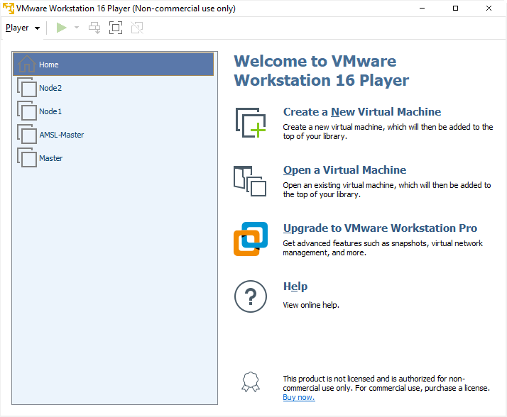

I have used **ubuntu-21.04-desktop-amd64.iso** to configure Master and Worker Nodes.

Master Node Configuration

1. Disk size - 20gb
2. Memory - 4gb
3. Number of processor core - 4

Worker Nodes Configuration

1. Disk size - 30gb
2. Memory - 8gb
3. Number of processor core - 4

We are going to update Hostname and hosts, static IP and Hosts on each Virtual Machine during configuration.

We are going to configure each of Virtual Machine with below Hostname and static IP addresses.

|  |  |  |
| --- | --- | --- |
|  | **Host Name** | **IP Address** |
| **Master** | amsl-master | 192.168.254.10 |
| **Node 1** | amsl-n1 | 192.168.254.11 |
| **Node 2** | amsl-n2 | 192.168.254.12 |

# Configure Master Node

## Step 1: Configure Host name, Hosts file and define a static IP address

1. Login into Master VM and open Terminal.
2. Write below command to update the host name.

sudo nano /etc/hostname

A text editor will open and update the name to amsl-master and save and exit.

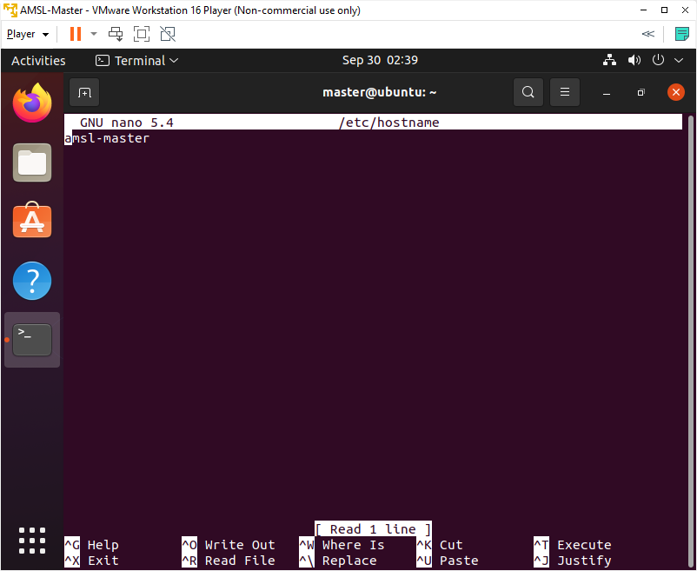

1. Write below command to identify the name of the Ethernet interface.

ip link

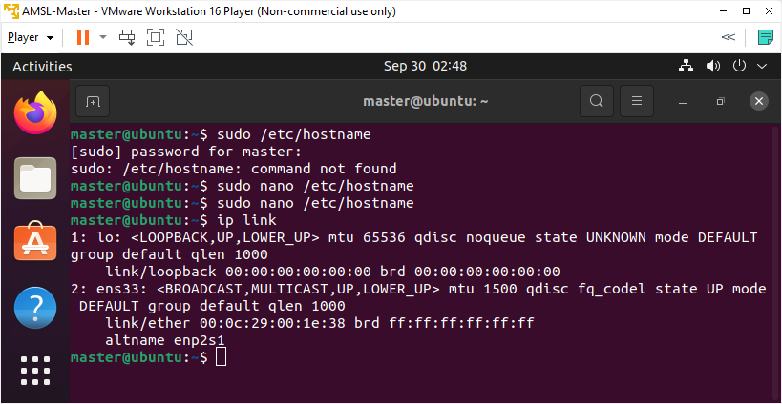

As we can see that our ethernet interface name is ens33.

1. To assign a static IP address on the network interface, open the YAML configuration file with a text editor with below command.

sudo nano /etc/netplan/01-network-manager-all.yaml

1. Update the page with below code.

network:

version: 2

renderer: NetworkManager

ethernets:

ens33:

dhcp4: false

addresses: [192.168.254.10/16]

gateway4: 192.168.254.2

nameservers:

addresses: [192.168.254.2,8.8.8.8]

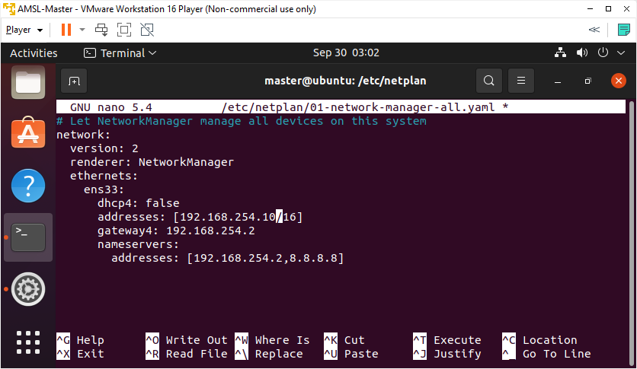

1. Save and exit.
2. Apply the changes by running the following command.

sudo netplan apply

1. Now we are going to update hosts file, as we have decided earlier about the host name and IP addresses of each Node. Write below command to open the hosts editor.

sudo nano /etc/hosts

1. Hosts file includes name to IP mappings for VMs. Update the page with below text.

192.168.254.10 amsl-master

192.168.254.11 amsl-n1

* + - 1. amsl-n2

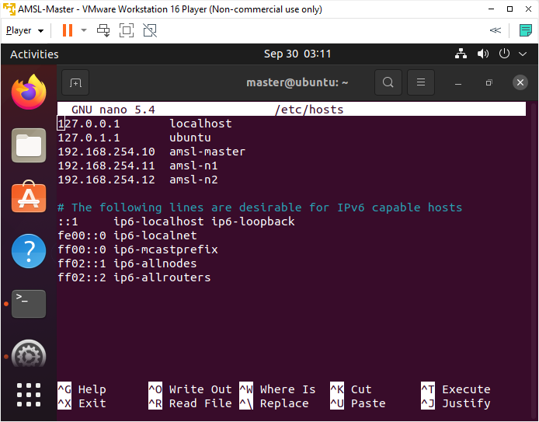

1. Save and exit.
2. Reboot the system.

## Step 2: Installation of OpenSSH-Server

Now we have to install openshh-server. Run the following command:

sudo apt-get install openssh-server

## Step 3: Turn Off Swap Space

1. We need disable swap before we start doing any other process. Write below command to swapoff.

sudo swapoff -a

1. Open fstab file and delete or comment swap line as below, I have commented the swapfile line. Write below command to open fstab file.

sudo nano /etc/fstab

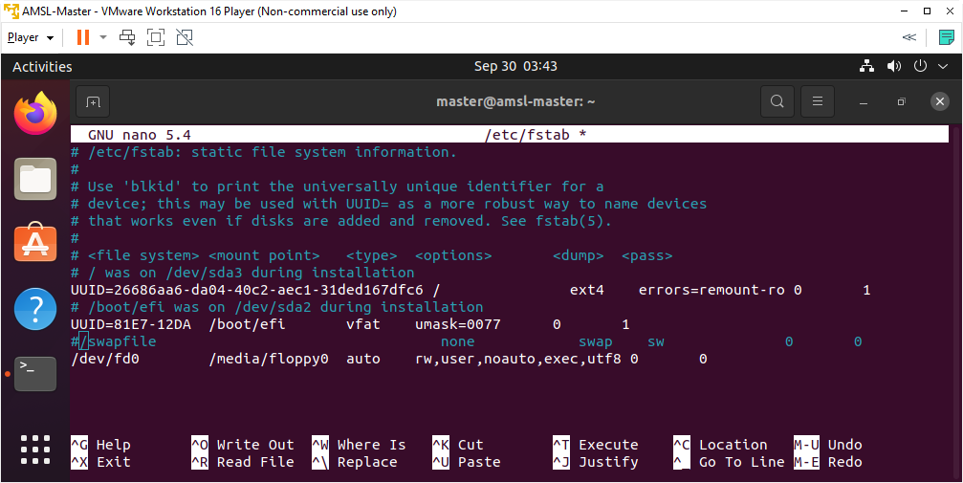

1. Save & exit.
2. Reboot the system.

## Step 4: Installation and Configuration of Containerd

We are going to load two modules and configure them to load on boot before start installing Containerd.

1. Write below commands to load modules.

sudo modprobe overlay

sudo modprobe br_netfilter

1. Write below command to make sure loaded modules are set on boot.

cat <<EOF | sudo tee /etc/modules-load.d/containerd.conf

overlay

br_netfilter

EOF

1. Now we need to Setup required sysctl parameters which persist across reboots. Write below command.

cat <<EOF | sudo tee /etc/sysctl.d/99-kubernetes-cri.conf

net.bridge.bridge-nf-call-iptables = 1

net.ipv4.ip_forward = 1

net.bridge.bridge-nf-call-ip6tables = 1

EOF

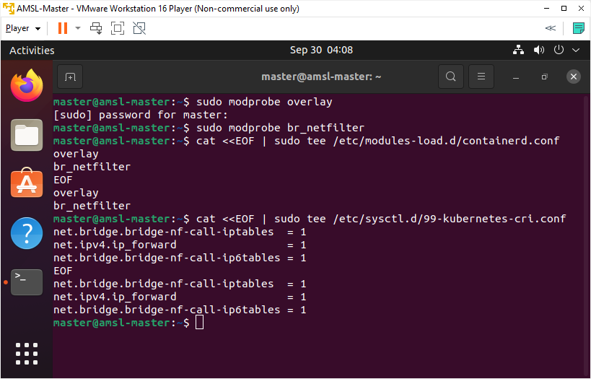

1. Apply sysctl parameters without reboot with below command.

sudo sysctl --system

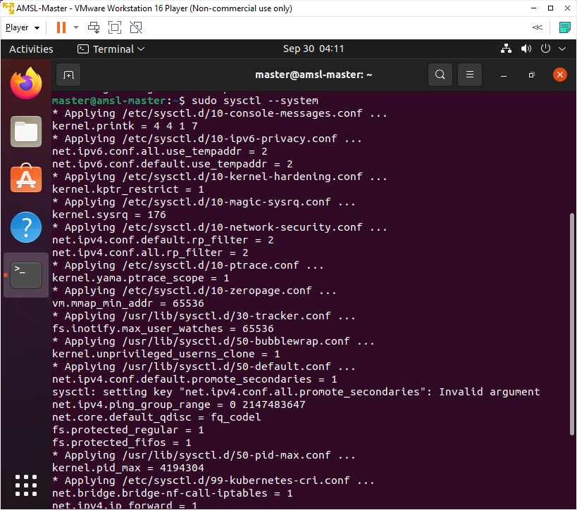

1. Now is the time to install containerd. Write below commands to install containerd.

sudo apt-get update

sudo apt-get install -y containerd

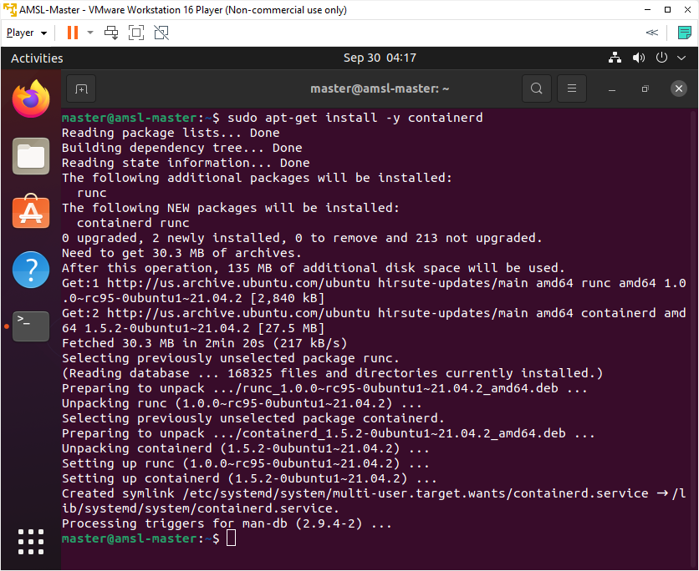

1. We need to apply some configuration specific to containerd, first we will create a directory for a containerd configuration file to keep, then we will use containerd command to generate default configuration file and write the generated output to config.toml file with below commands.

sudo mkdir -p /etc/containerd

sudo containerd config default | sudo tee /etc/containerd/config.toml

1. Now we are going to set the cgroup driver for containerd to systemd which is required for the kubelet. Write below command to open the config.toml file.

sudo nano /etc/containerd/config.toml

1. In the config.toml file, update SystemdCgroup. change it from SystemdCgroup = false to SystemdCgroup = true

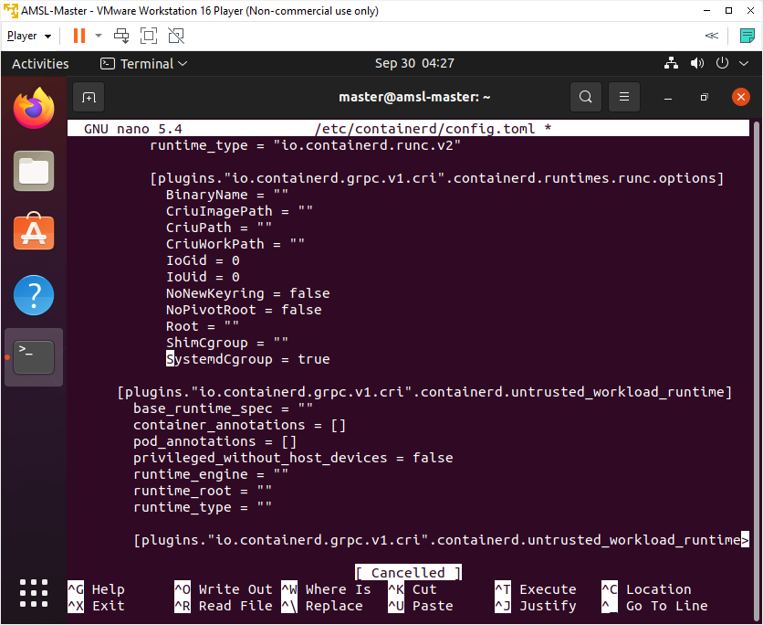

1. Save & Exit.
2. Restart containerd with the new configuration. Write below command.

sudo systemctl restart containerd

## Step 5: Install and Configure Kubeadm, Kubelet and Kubectl

1. Now we are going to Install Kubernetes packages - kubeadm, kubelet and kubectl.

First we need to add Google's apt repository gpg key to our system so that we can trust the repository. Write below command. (please install curl if not installed)

sudo apt-get install -y curl

curl -s https://packages.cloud.google.com/apt/doc/apt-key.gpg | sudo apt-key add -

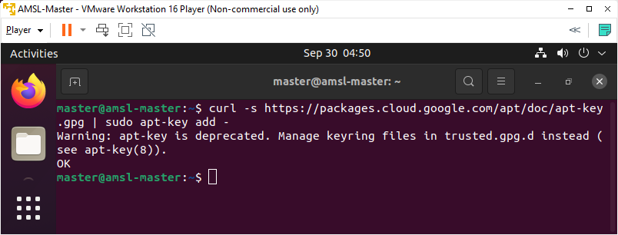

1. Add the Kubernetes apt repository and that going to configure that local apt repository to our local system. Write below command.

sudo bash -c 'cat <<EOF >/etc/apt/sources.list.d/kubernetes.list

deb https://apt.kubernetes.io/ kubernetes-xenial main

EOF'

1. Update the package list and use apt-cache policy to inspect versions available in the repository. Write below command.

sudo apt-get update

apt-cache policy kubelet | head -n 20

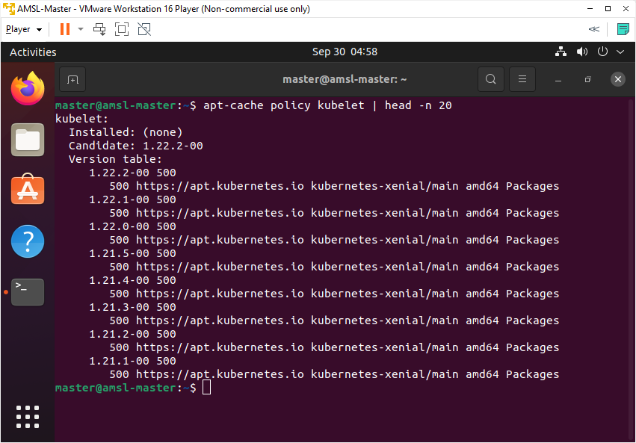

In the output, we can see different versions of kubelet that are available as packages in the repository.

1. Now we are going to Install the required packages, if needed we can request a specific version.

VERSION=1.21.0-00

sudo apt-get install -y kubelet=$VERSION kubeadm=$VERSION kubectl=$VERSION

1. Write below command to mark all four packages hold and this will prevent these packages from being updated.

sudo apt-mark hold kubelet kubeadm kubectl containerd

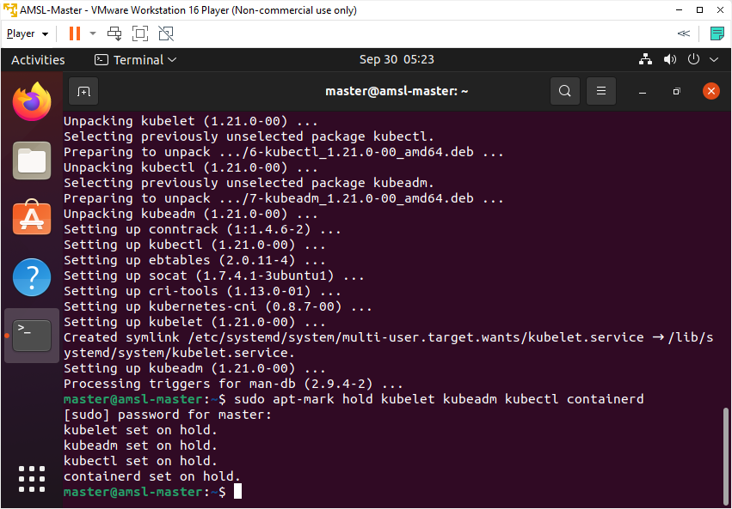

1. Check the status of kubelet with below command. The kubelet will enter a crashloop until a cluster is created or the node is joined to an existing cluster.

sudo systemctl status kubelet.service

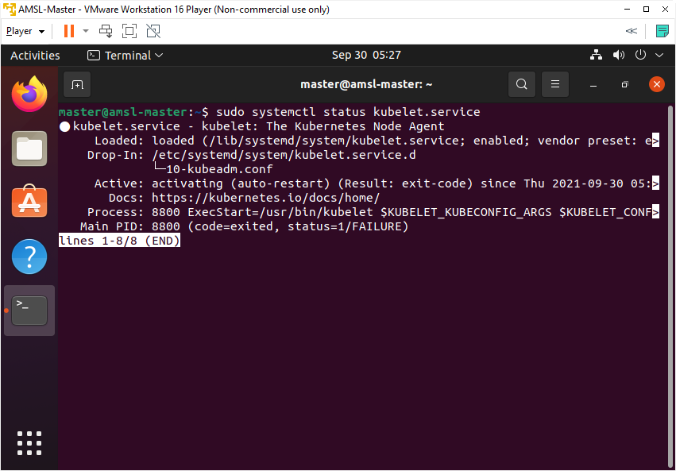

1. Check the status of Containerd with below command.

sudo systemctl status containerd.service

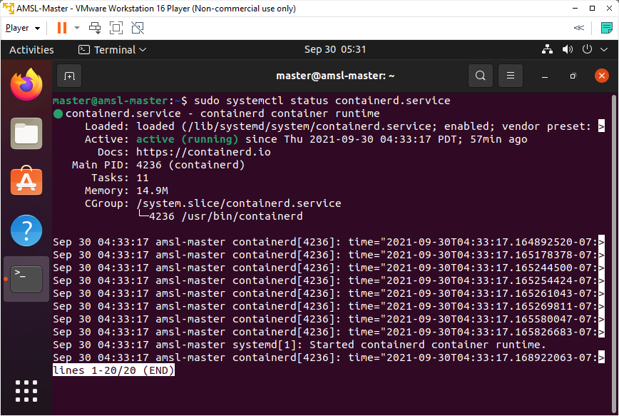

We can see that Containerd is active and running, so it is up and loaded and in a proper state.

1. Ensure Kubelet and Containerd are set to start when the system starts up. Write below command to execute.

sudo systemctl enable kubelet.service

sudo systemctl enable containerd.service

## Step 6: Install and Configure Control Plane Node

Let’s understand first the process of bootstrapping a cluster with Kubeadm. Kubeadm is a tool that we can use to manage the process of creating our cluster. It's going to walk through various phases, and build and configure our cluster for us, and right now we're going to walk through each one of those steps to get the idea of what goes on during the creation of a Kubernetes cluster.

Now, to bootstrap a cluster at the command line, you'll type kubeadm init, and it's going to begin the process of creating a cluster.

The first phase is the pre‑flight checks. kubeadm is going to do here for you is execute a series of checks that will help ensure a successful cluster creation. So things like ensuring that you have the right permissions on the system that you're working with. It's also going to verify that you have the appropriate system resources on this box in terms of CPU and memory, and another important pre‑flight check that it executes is it checks to see if there's a compatible container runtime on this system, and if it's up and running. If any of these checks fails, kubeadm will report the error and stop the cluster creation process.

The next thing that kubeadm does for us is it creates a certificate authority for us. Kubernetes uses certificates for both authentication and encryption.

In the next phase, kubeadm generates kubeconfig files for us for the various cluster components of Kubernetes, so that they can locate and authenticate against the API server.

Then the next phase is generating static pod manifests. Static pod manifests are going to be generated for each of the control plane pods, and what's going to happen here is they're going to be written to the file system and the kubelet is going to monitor that location. If it finds a pod manifest there, kubelet's going to start up the pods defined in that manifest.

And then, after those static pod manifests are generated, kubeadm is going to wait for the control plane pods to start up. So the API server, etcd, and so on, will be started up as pods.

Then kubeadm goes on to taint the control plane node which means Kubernetes schedules pods, it will never schedule user pods onto the control plane node, it will only schedule system pods to run on that control plane node.

Then, kubeadm generates a bootstrap token used for joining additional nodes to the cluster, and then finally, in its final phase, it will start up any add‑on pods, such as DNS and kube‑proxy pods. The process that we just described here is the default process if you use kubeadm init with no parameters. This bootstrapping process is very customizable, and you can build more complex or customized clusters using kubeadm command line parameters, or even a YAML manifest configuration file to describe a cluster's configuration.

In the cluster configuration file, we will specify that we're using containerd as our container runtime, and we'll also define the C group driver for the kubelet, which is systemd. The reason why we're using systemd as our C group driver is because Ubuntu is a systemd based system.

### 6.1: Creating a Cluster

1. Create our kubernetes cluster, specify a pod network range matching that in calico.yaml. Only on the Control Plane Node, download the yaml files for the pod network. Write below command.

wget https://docs.projectcalico.org/manifests/calico.yaml

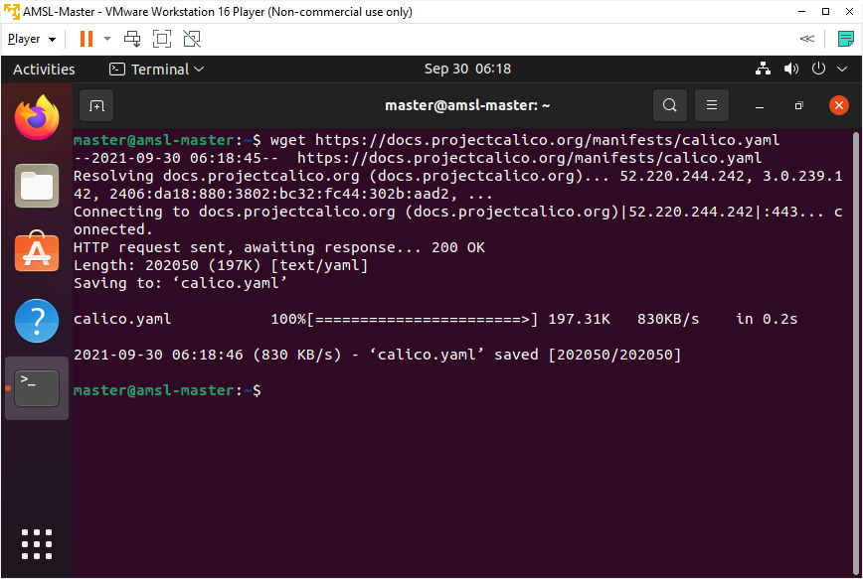

1. Open calico.yaml and find the setting for Pod Network IP address range CALICO_IPV4POOL_CIDR, adjust if needed for your infrastructure to ensure that the Pod network IP, range doesn't overlap with other networks in our infrastructure.

sudo nano calico.yaml

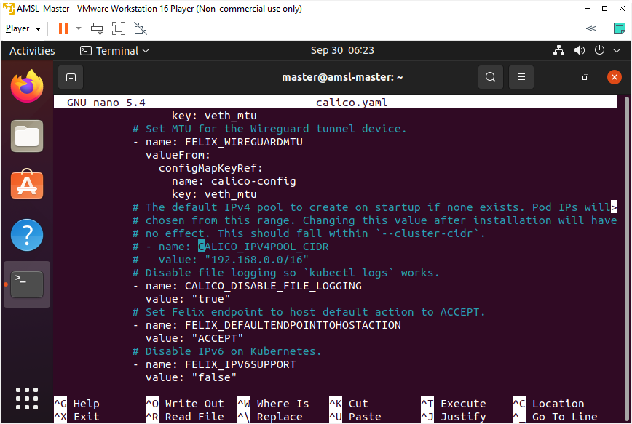

As you can see the value for CALICO_IPV4POOL_CIDR is 192.168.0.0/16. All pods are going to be allocated IP’s from that network range. We need to make sure that the network range should not overlap with other network in our infracture. Exit without update anything in this page.

1. Generate a default kubeadm init configuration file. This defines the settings of the cluster being built. Write below command to create kubeconfig init configuration file. This configuration file is going to define the settings of the cluster that kubeadm going to built for us.

kubeadm config print init-defaults | tee ClusterConfiguration.yaml

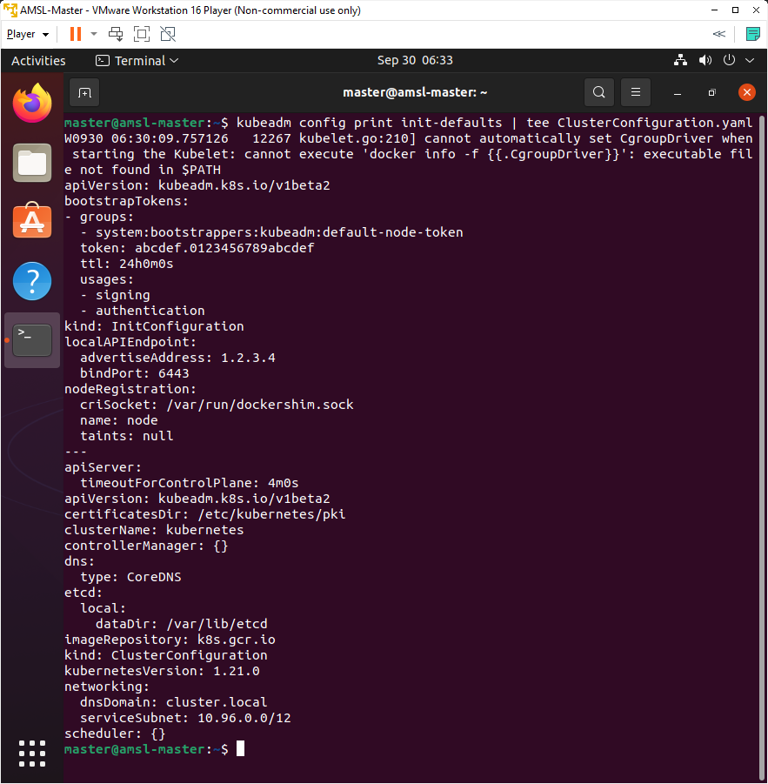

advertiseAddress is the IP address of the API Server and we are going to update that to our IP address of our Control Plane Node which is our cluster going to be 192.168.254.10. we are also going to update criSocket from dockershim to container runtime we are using which is containerd.

1. Change the address of the localAPIEndpoint.advertiseAddress to the Control Plane Node's IP address. Write below command.

sed -i 's/ advertiseAddress: 1.2.3.4/ advertiseAddress: 192.168.254.10/' ClusterConfiguration.yaml

1. Set the CRI Socket to point to containerd with below command.

sed -i 's/ criSocket: \/var\/run\/dockershim\.sock/ criSocket: \/run\/containerd\/containerd\.sock/' ClusterConfiguration.yaml

1. Added configuration to set the node name for the control plane node to the actual hostname.

sed -i 's/ name: node/ name: amsl-master/' ClusterConfiguration.yaml

1. Set the cgroupDriver to system for the kubelet. This configuration is not exist default that generated by kubeadm so we are going to add that to our cluster configuration file. Write below command.

cat <<EOF | cat >> ClusterConfiguration.yaml

---

apiVersion: kubelet.config.k8s.io/v1beta1

kind: KubeletConfiguration

cgroupDriver: systemd

EOF

1. Review the Cluster configuration file, update the version to match what you've installed. Write below command.

cat ClusterConfiguration.yaml

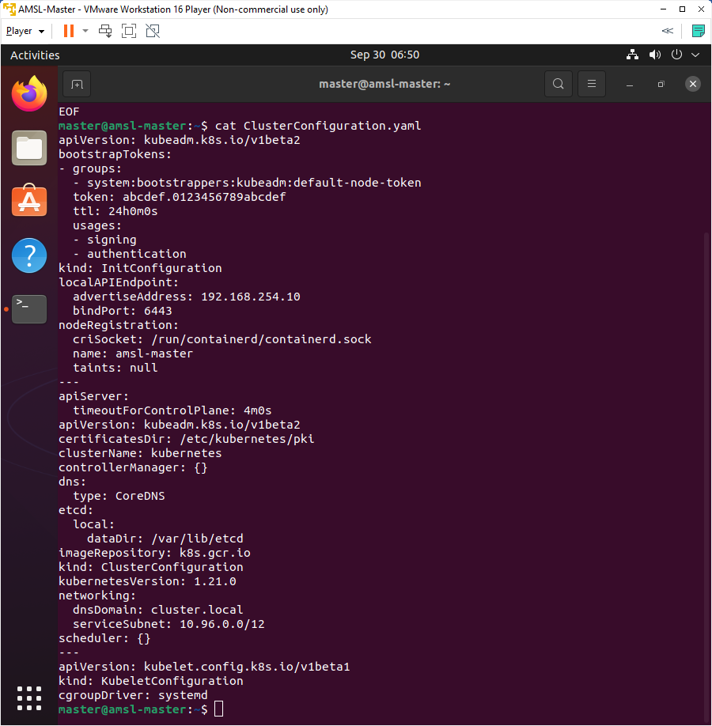

1. Now we are going to bootstrap our cluster and going to add CRI socket since there's a check for docker in the kubeadm init process.

sudo kubeadm init \

--config=ClusterConfiguration.yaml \

--cri-socket /run/containerd/containerd.sock

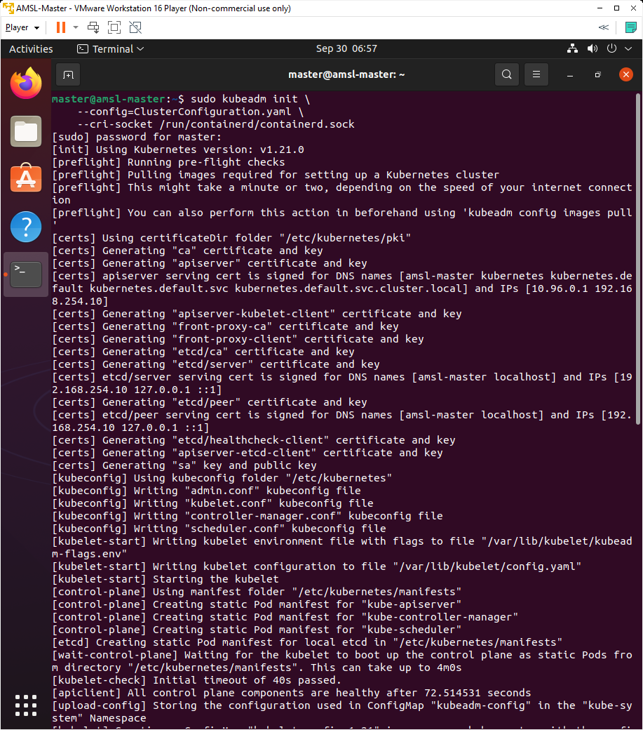

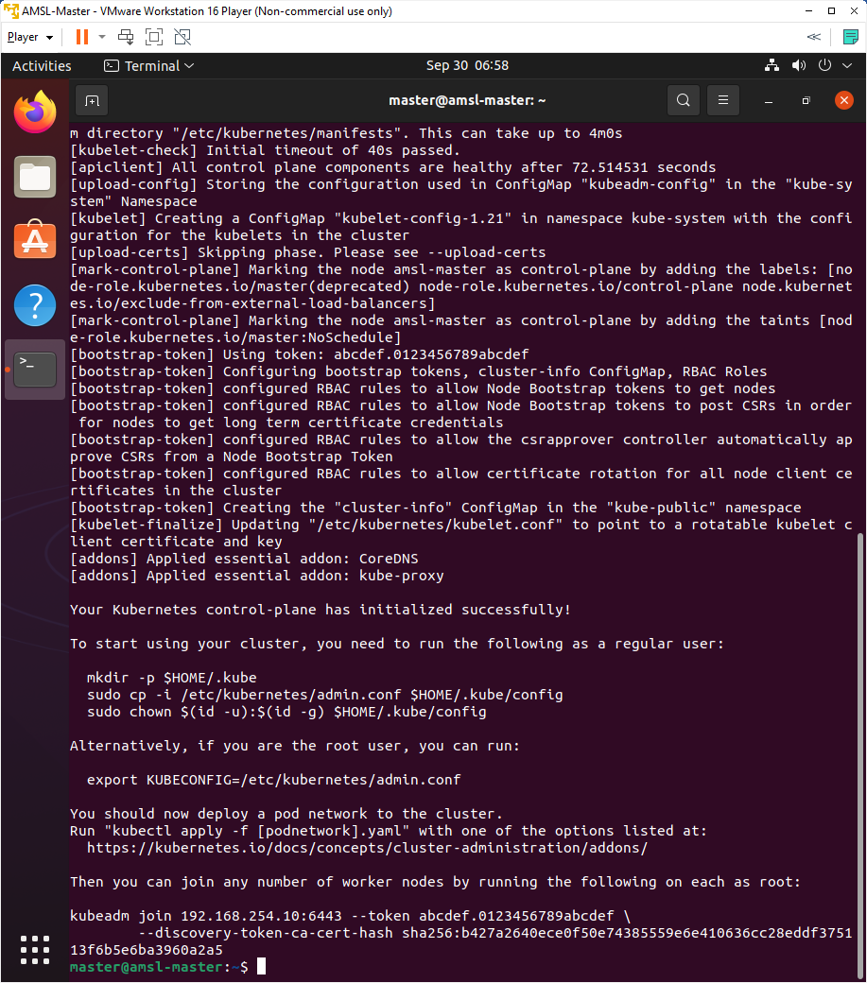

On the above output you will see the kubernetes verision 1.21.0.

The next phase is preflight checks where that goes through those preflight checks.

In the next phase, it creates the CA for us, or that certificate authority, and then goes through a series of commands to generate certificates for each one of the control plane Pods.

Then it goes into the kubeconfig phase generating and writing out the kubeconfig files for admin.conf, kubelet.conf, controller‑manager.conf, and scheduler.conf. It then creates the static Pod manifests for each of the control plane Pods. There we see kube‑apiserver, kube‑controller‑manager, and kube‑scheduler. It writes those all into /etc/kubernetes/manifests.

After the control plane Pod's static Pod manifests are generated, it also creates a static Pod manifest for etcd.

Then at that point in time, once all the control plane Pod's static Pod manifests are in place, it goes into a wait state waiting for all those static Pods to start up, and so there we see wait for control plane. Then a few seconds later we see all control plane components are healthy.

We can then see it creates the add‑on Pods. So there we see CoreDNS is created and kube‑proxy. Now the most crucial output in all of this here is seeing the output that says your Kubernetes control‑plane has initialized successfully! You know your control plane node is up and running after you seeing that and now we see some code here that describes how we can connect to our cluster as a user and that will copy the kubeconfig file for admin.conf from /etc/kubernetes into our HOME directory and then sets the permissions on that.

At the bottom there, we can see the join command to join a node to the cluster, and we see kubeadm join and then the IP address of our API server, which now is populated with the correct address 192.168.254.10.

As our control plane node up and running, let's move forward and execute those commands that we need to access our control plane node.

1. Configure our account on the Control Plane Node to have admin access to the API server from a non-privileged account. Create a directory by below command.

mkdir -p $HOME/.kube

1. Now copy that admin.conf file into our users home directory so we can use that to connect to kubernetes.

sudo cp -i /etc/kubernetes/admin.conf $HOME/.kube/config

1. We are now going to change the permissions on that so regular user can access the file.

sudo chown $(id -u):$(id -g) $HOME/.kube/config

### 6.2: Creating a Pod Network

1. Deploy yaml file for pod network References with below command.

kubectl apply -f calico.yaml

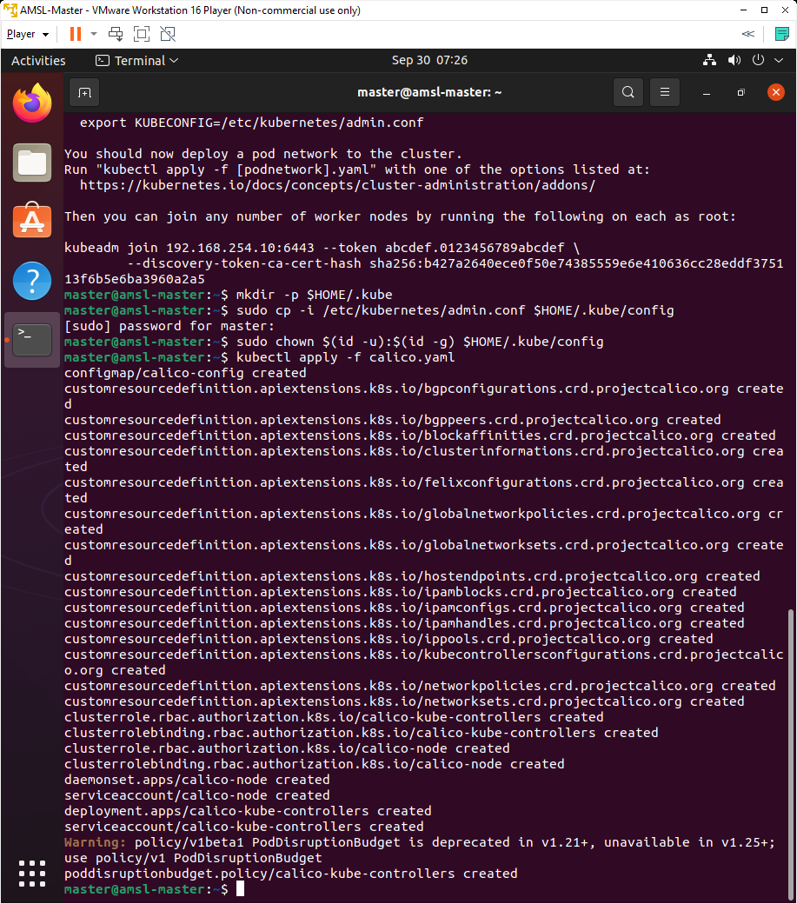

1. Look for the all the system pods and calico pods to change to Running. The DNS pod won't start (pending) until the Pod network is deployed and Running.

kubectl get pods --all-namespaces

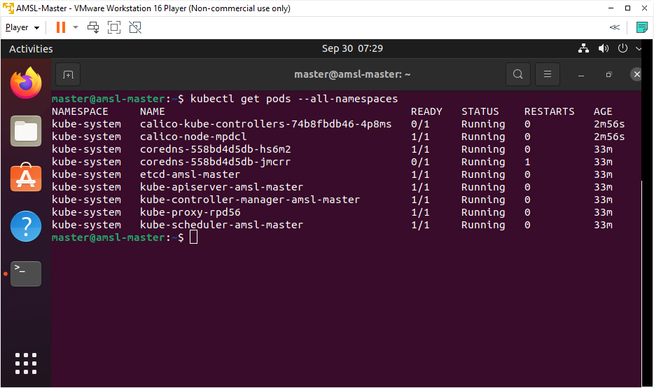

All pods are running.

Control plane pods:

* etcd-amsl-master
* kube-apiserver-amsl-master
* kube-controller-manager-amsl-master
* kube-scheduler-amsl-master

Kube proxy Pod:

* kube-proxy-rpd56 (This pod is going to implement service networking on individual nodes)

Core DNS Pods:

* coredns-558bd4d5db-hs6m2
* coredns-558bd4d5db-jmcrr

Calico Pods:

* calico-kube-controllers-74b8fbdb46-4p8ms
* calico-node-mpdcl

1. You can also check with below command for continuous iteration status of each pods.

kubectl get pods --all-namespaces --watch

1. Get a list of our current nodes with below command

kubectl get nodes

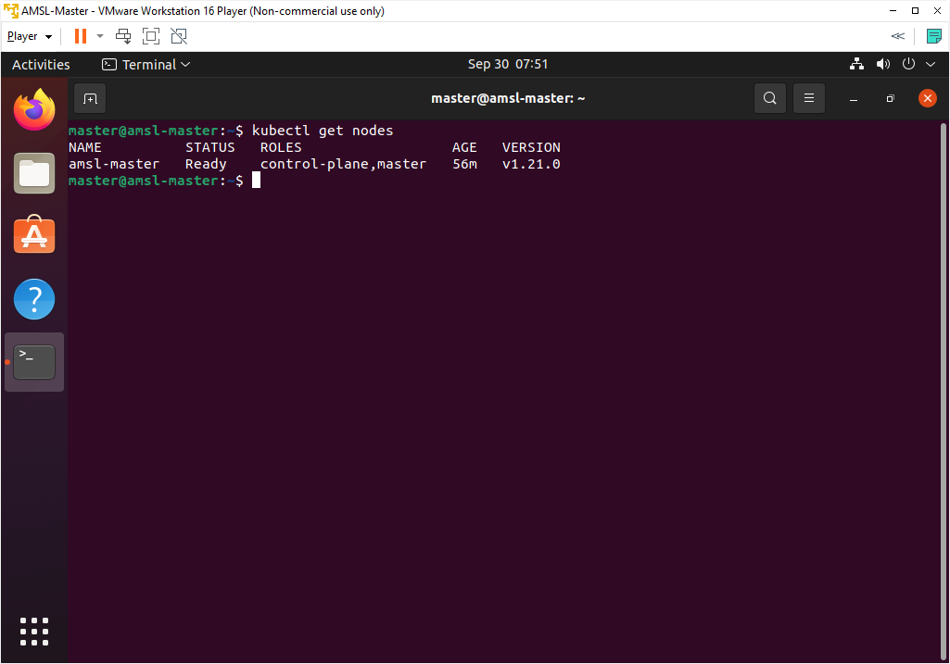

As you can see only one node which is master node we just configured.

1. Check out the systemd unit and it's no longer crash looping because it has static pods to start.

sudo systemctl status kubelet.service

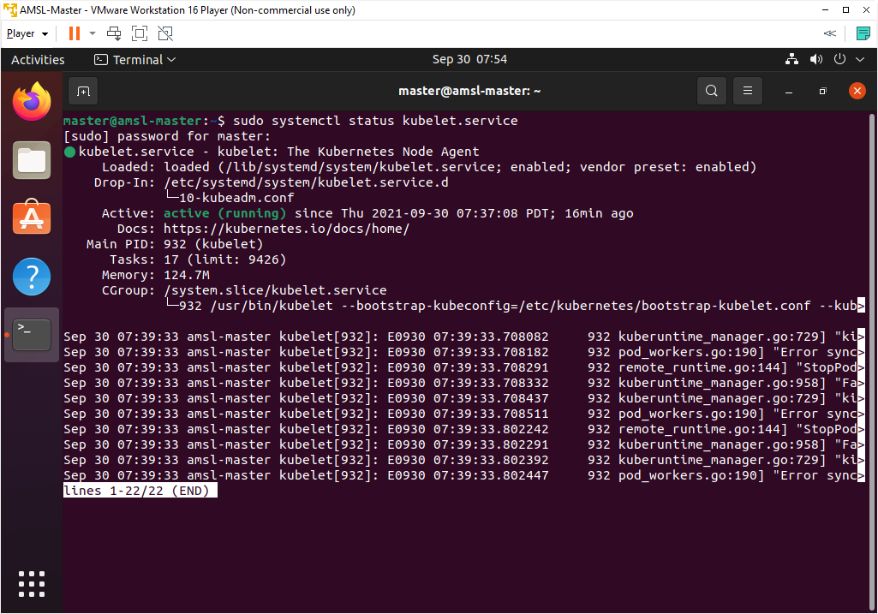

1. You can exit by pressing ( ctrl+c );

### 6.3: Static Pod manifests

1. Let's check out the static pod manifests on the Control Plane Node with below command.

ls /etc/kubernetes/manifests

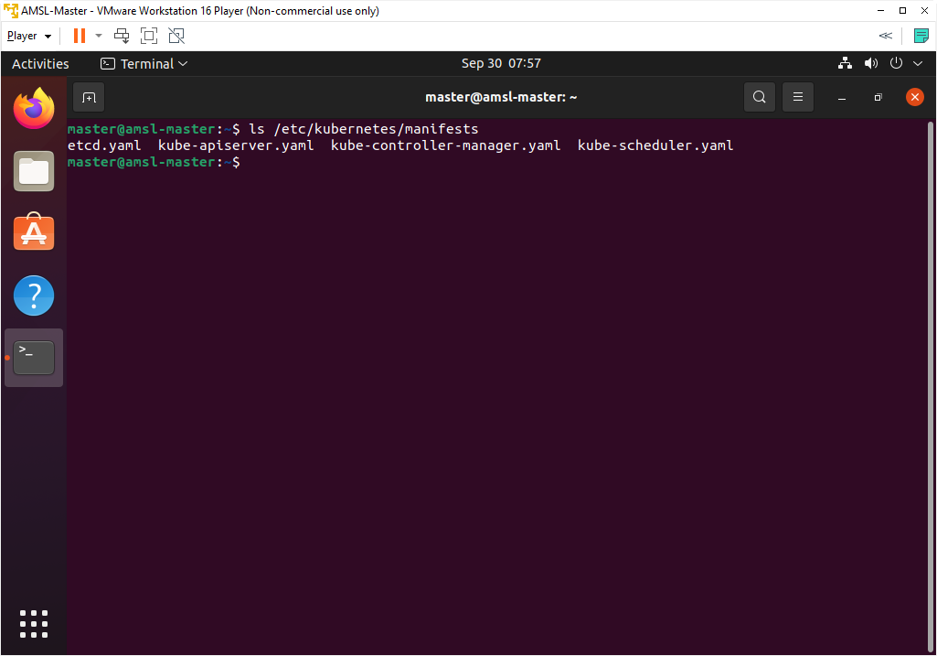

1. You can also look more closely at API server and etcd's manifest with below command.

sudo more /etc/kubernetes/manifests/etcd.yaml

sudo more /etc/kubernetes/manifests/kube-apiserver.yaml

1. Check out the directory where the kubeconfig files live for each of the control plane pods.

ls /etc/kubernetes

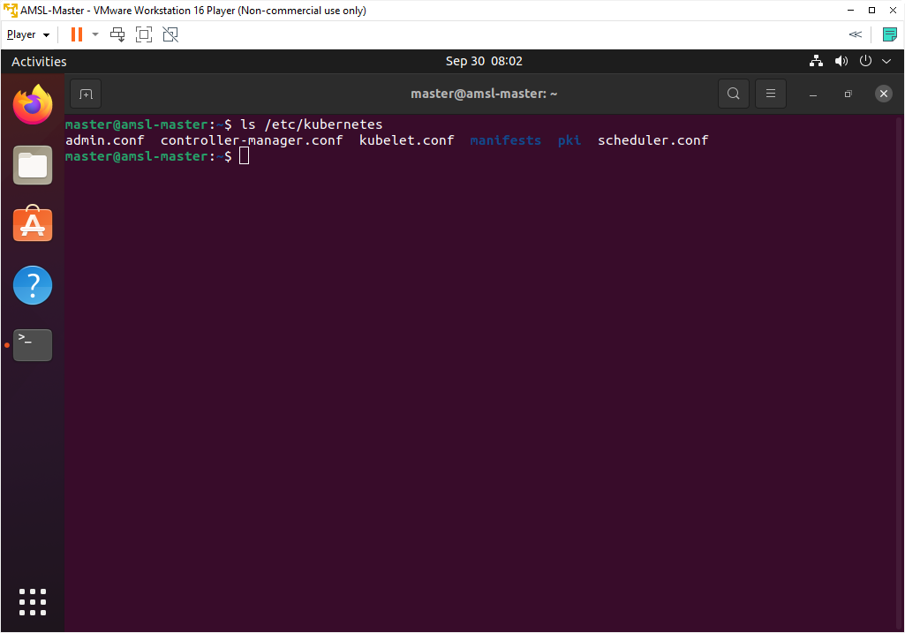

# Configure Worker Nodes

## Step 1: Configure Host name, Hosts file and define a static IP address

1. Login into Node1 VM and open Terminal.
2. Write below command to update the host name.

sudo nano /etc/hostname

A text editor will open and update the name to amsl-n1 and save and exit.

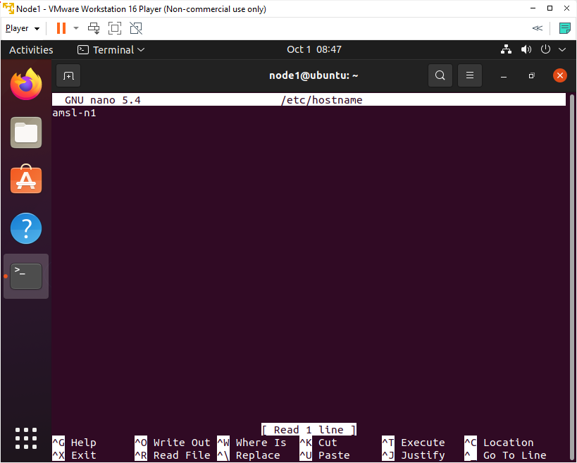

1. Write below command to identify the name of the Ethernet interface.

ip link



As we can see that our ethernet interface name is ens33.

1. To assign a static IP address on the network interface, open the YAML configuration file with a text editor with below command.

sudo nano /etc/netplan/01-network-manager-all.yaml

1. Update the page with below code.

network:

version: 2

renderer: NetworkManager

ethernets:

ens33:

dhcp4: false

addresses: [192.168.254.11/16]

gateway4: 192.168.254.2

nameservers:

addresses: [192.168.254.2,8.8.8.8]

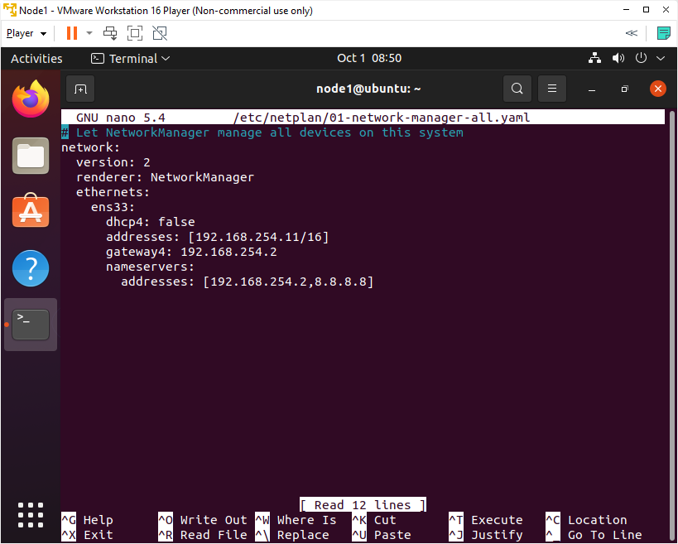

1. Save and exit.
2. Apply the changes by running the following command.

sudo netplan apply

1. Now we are going to update hosts file, as we have decided earlier about the host name and IP addresses of each Node. Write below command to open the hosts editor.

sudo nano /etc/hosts

1. Hosts file includes name to IP mappings for VMs. Update the page with below text.

192.168.254.10 amsl-master

192.168.254.11 amsl-n1

192.168.254.12 amsl-n2



1. Save and exit.
2. Reboot the system.

## Step 2: Installation of OpenSSH-Server

Now we have to install openshh-server. Run the following command:

sudo apt-get install openssh-server

## Step 3: Turn Off Swap Space

1. We need disable swap before we start doing any other process. Write below command to swapoff.

sudo swapoff -a

1. Open fstab file and delete or comment swap line as below, I have commented the swapfile line. Write below command to open fstab file.

sudo nano /etc/fstab

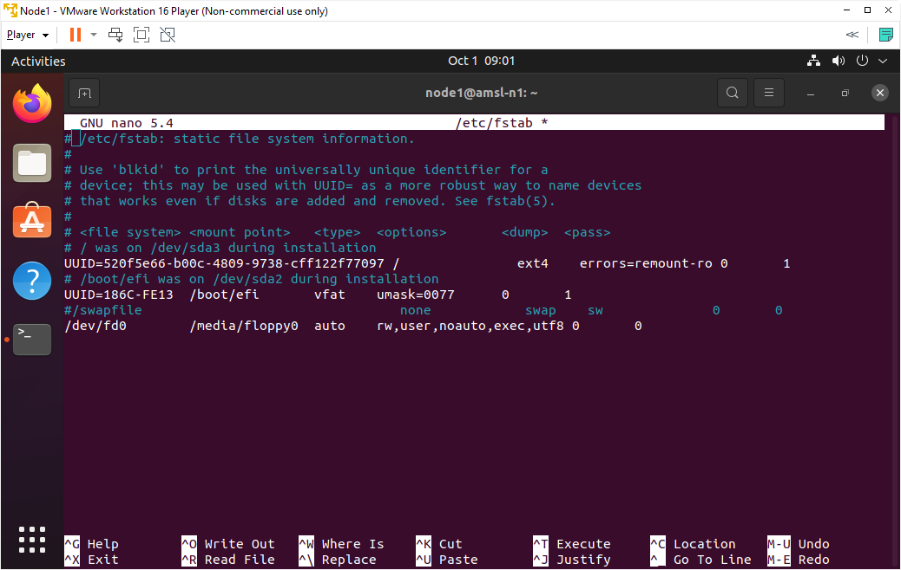

1. Save & exit.
2. Reboot the system.

## Step 4: Installation and Configuration of Containerd

We are going to load two modules and configure them to load on boot before start installing Containerd. The process of installing containerd is same as we did for Master Node.

1. Write below commands to load modules.

sudo modprobe overlay

sudo modprobe br_netfilter

1. Write below command to make sure loaded modules are set on boot.

cat <<EOF | sudo tee /etc/modules-load.d/containerd.conf

overlay

br_netfilter

EOF

1. Now we need to Setup, required sysctl parameters which persist across reboots. Write below command.

cat <<EOF | sudo tee /etc/sysctl.d/99-kubernetes-cri.conf

net.bridge.bridge-nf-call-iptables = 1

net.ipv4.ip_forward = 1

net.bridge.bridge-nf-call-ip6tables = 1

EOF

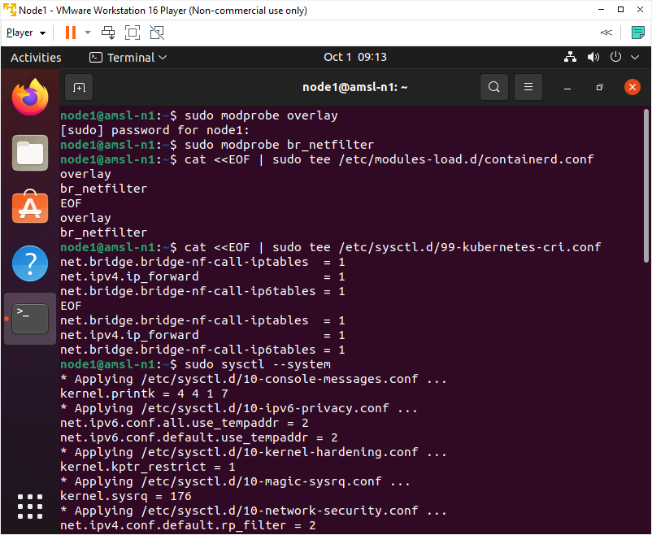

1. Apply sysctl parameters without reboot with below command.

sudo sysctl --system

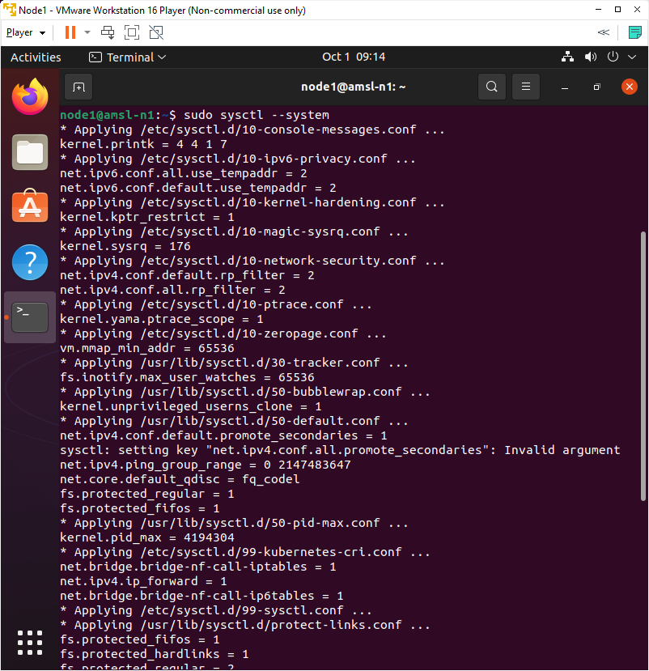

1. Now is the time to install containerd. Write below commands to install containerd.

sudo apt-get update

sudo apt-get install -y containerd

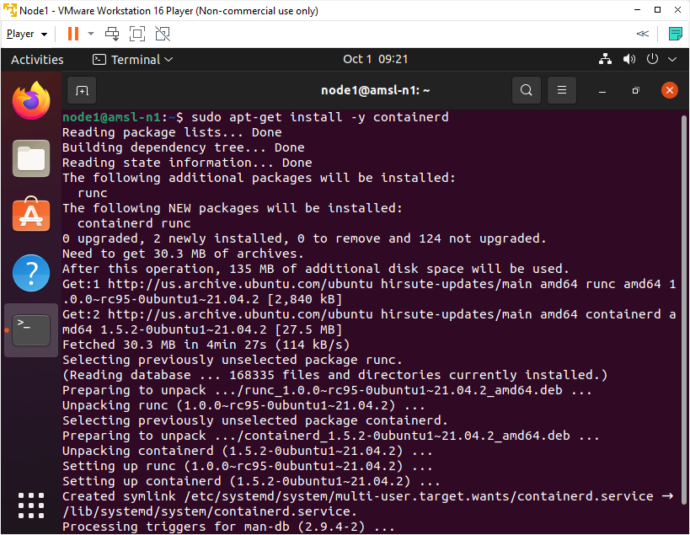

1. We need to apply some configuration specific to containerd, first we will create a directory for a containerd configuration file to keep, then we will use containerd command to generate default configuration file and write the generated output to config.toml file with below commands.

sudo mkdir -p /etc/containerd

sudo containerd config default | sudo tee /etc/containerd/config.toml

1. Now we are going to set the cgroup driver for containerd to systemd which is required for the kubelet. Write below command to open the config.toml file.

sudo nano /etc/containerd/config.toml

1. In the config.toml file, update SystemdCgroup. change it from SystemdCgroup = false to SystemdCgroup = true



1. Save & Exit.
2. Restart containerd with the new configuration. Write below command.

sudo systemctl restart containerd

## Step 5: Install and Configure Kubeadm, Kubelet and Kubectl

1. Now we are going to Install Kubernetes packages - kubeadm, kubelet and kubectl.

First we need to add Google's apt repository gpg key to our system so that we can trust the repository. Write below command. (please install curl if not installed)

sudo apt-get install -y curl

curl -s https://packages.cloud.google.com/apt/doc/apt-key.gpg | sudo apt-key add -

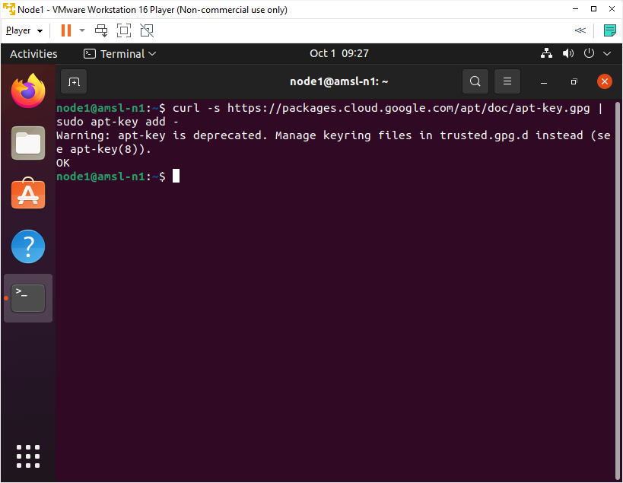

1. Add the Kubernetes apt repository and that going to configure that local apt repository to our local system. Write below command.

sudo bash -c 'cat <<EOF >/etc/apt/sources.list.d/kubernetes.list

deb https://apt.kubernetes.io/ kubernetes-xenial main

EOF'

1. Update the package list and use apt-cache policy to inspect versions available in the repository. Write below command.

sudo apt-get update

sudo apt-cache policy kubelet | head -n 20

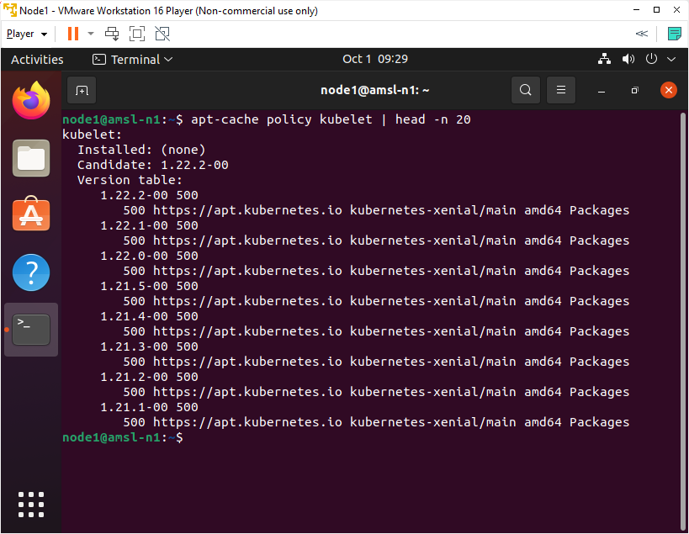

In the output, we can see different versions of kubelet that are available as packages in the repository.

1. Now we are going to Install the required packages, if needed we can request a specific version.

VERSION=1.21.0-00

sudo apt-get install -y kubelet=$VERSION kubeadm=$VERSION kubectl=$VERSION

1. Write below command to mark all four packages hold and this will prevent these packages from being updated.

sudo apt-mark hold kubelet kubeadm kubectl containerd

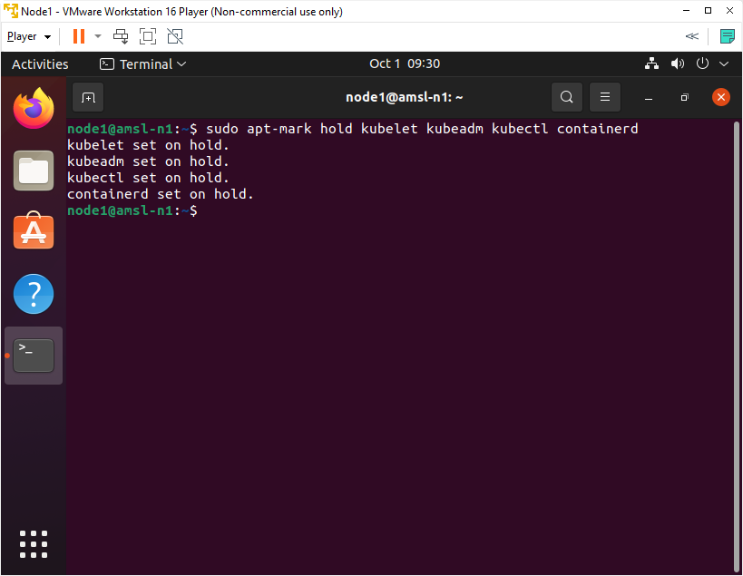

1. Check the status of kubelet with below command. The kubelet will enter a crashloop until a cluster is created or the node is joined to an existing cluster.

sudo systemctl status kubelet.service

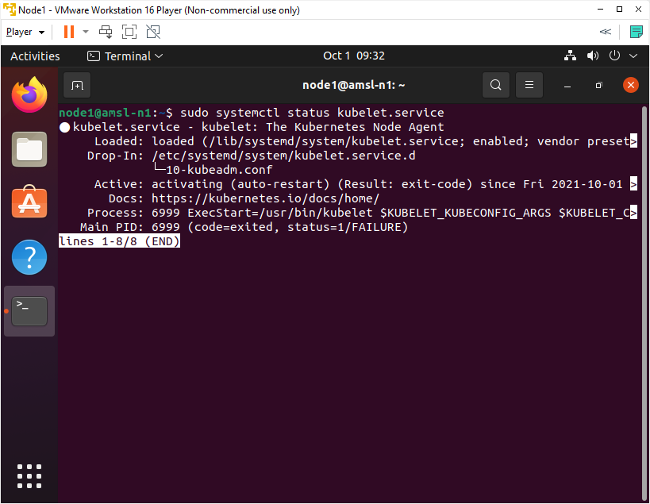

*** You can exit by pressing ( ctrl+c ) ***

1. Check the status of Containerd with below command.

sudo systemctl status containerd.service

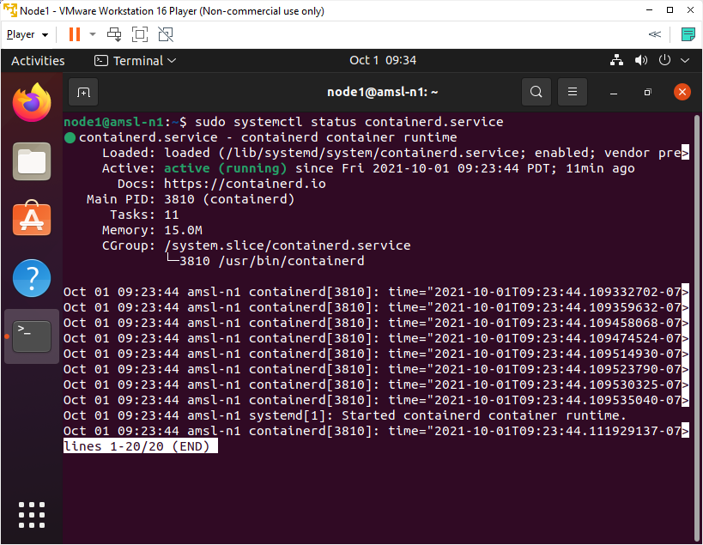

We can see that Containerd is active and running, so it is up and loaded and in a proper state.

1. Ensure Kubelet and Containerd are set to start when the system starts up. Write below command to execute.

sudo systemctl enable kubelet.service

sudo systemctl enable containerd.service

Please follow the same instruction to configure Node 2, except update the IP address to 192.168.254.12 and Host name to amsl-n2.

# Join the Node to the Cluster

As we have already configured Master and worker nodes, now is the time to connect Nodes with cluster. We going to need both bootstrap token and also the CA Cert hash to join nodes with cluster. We can copy these information from the output of kubeadm init.

Bootstrap token is a timed ticket and it has 24 hours lifecyle which means a new token need to be generate after 24 hours.

1. Login into Master Node and write below command to check if any token is active or not.

kubeadm token list

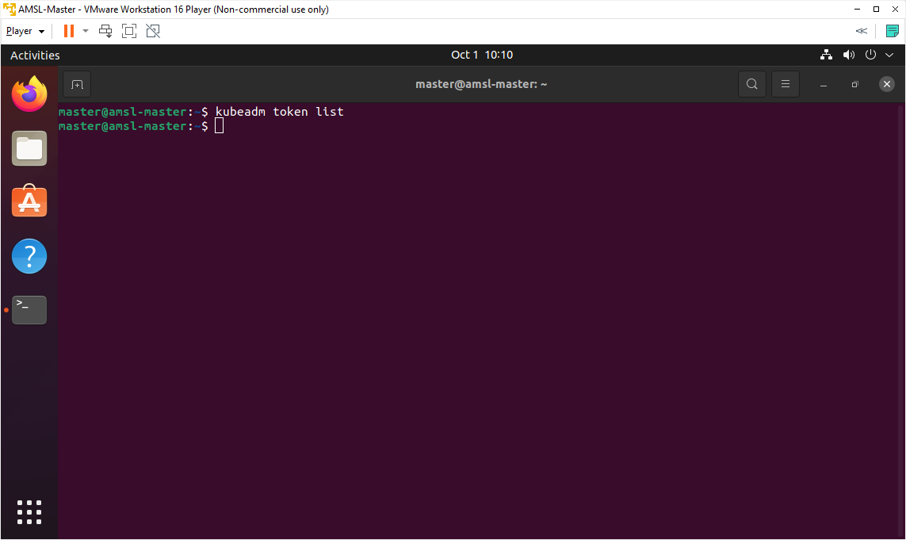

As we can see, we did not get any result because we don’t have any created token or token has been timed out or expired. In your case, you might get a token if you check after kubeadm init process.

1. Now we are going to generate a new token with below command.

kubeadm token create

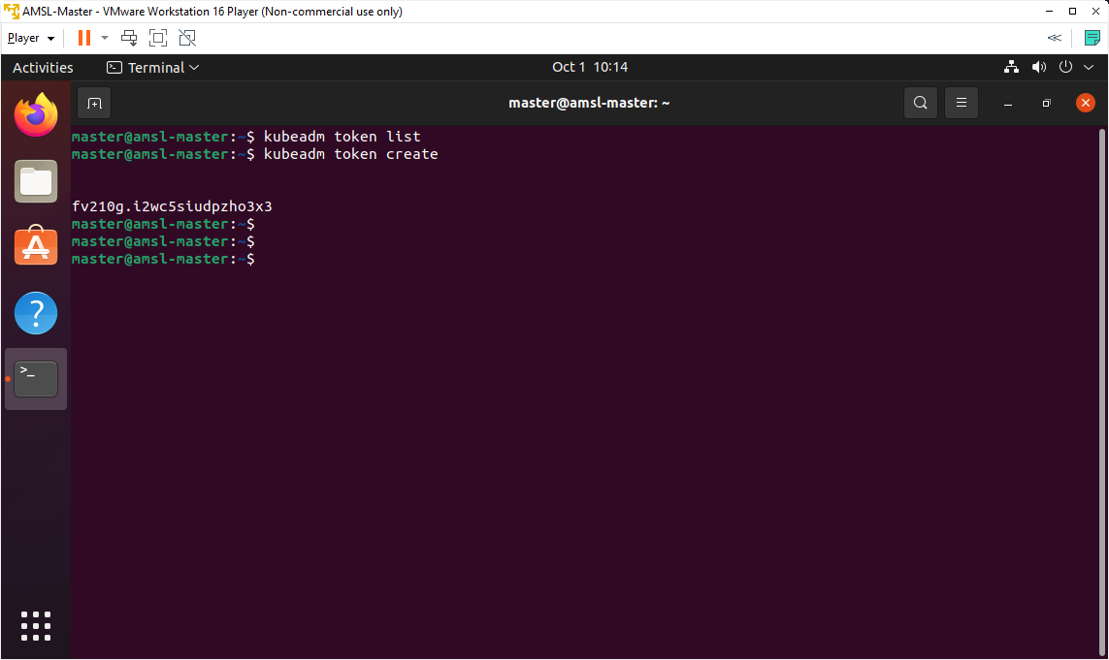

We can see that a new token has been created. If you check token list now, a new token will be found on the list.

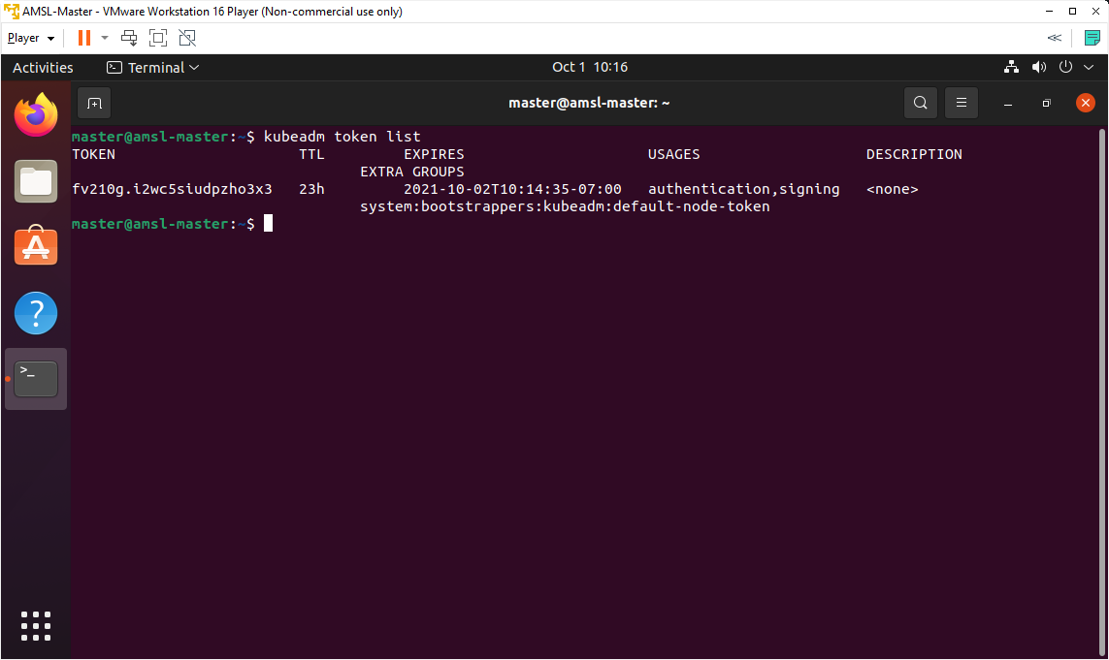

You can see that; token has 23-hour lifecycle left.

1. We can find CA Cert Hash on the Control Plane Node with below command.

openssl x509 -pubkey -in /etc/kubernetes/pki/ca.crt | openssl rsa -pubin -outform der 2>/dev/null | openssl dgst -sha256 -hex | sed 's/^.* //'

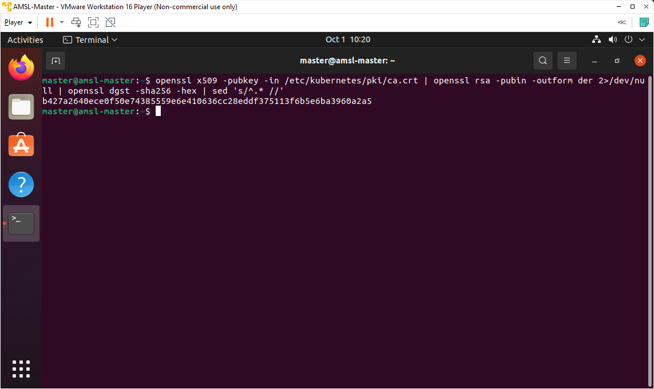

Now we can take all of these information and make the join command with kubeadm joins by specifying the bootstrap token and CA Cert Hash but there is another way to connect nodes with cluster. We are going to join nodes with cluster with command.

1. We can also use print-join-command to generate token and print the join command in the proper format. Write below command and generate the join command.

kubeadm token create --print-join-command

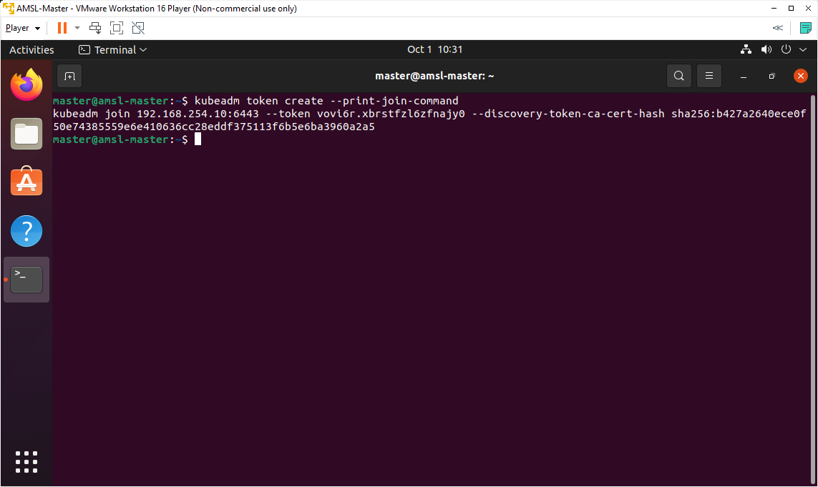

We can see above well-formatted join command with the proper parameters and values including the location of the API Server, the Bootstrap token and CA Cert Hash.

Now we are going to copy the above generated command and going to use this command on Worker nodes to connect with cluster.

1. Login into Node1 and use previously generated command from master node. In my case, generated command is below which I am going to use in Node1 and Node2.

sudo kubeadm join 192.168.254.10:6443 \  
--token vovi6r.xbrstfzl6zfnajy0 \  
--discovery-token-ca-cert-hash sha256:b427a2640ece0f50e74385559e6e410636cc28eddf375113f6b5e6ba3960a2a5

***Note: Above command will be different in your case. Use your generated command instead of using above command.

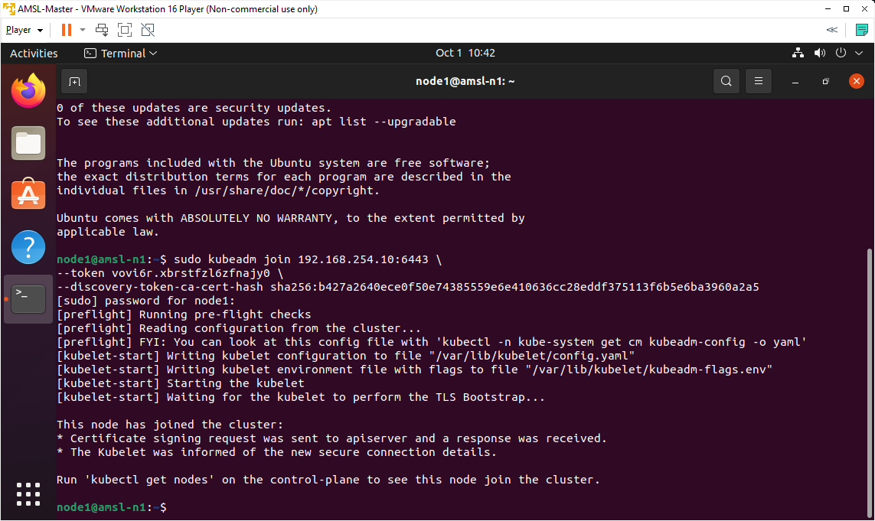

On the above output we can see, it executes the preflight checks first and then wait for the kubelet to perform the TLS Bootstrap process. We can also see from the bottom output that the node has been joined to the cluster.

We have use the same command on Node 2, in my case amsl-n2.

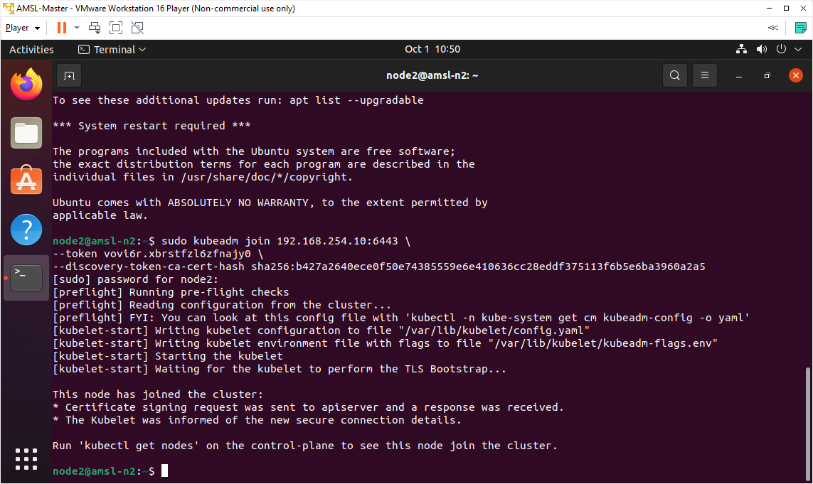

1. Login back to Control Plane or Master Node, write below command to verify all connected nodes.

kubectl get nodes

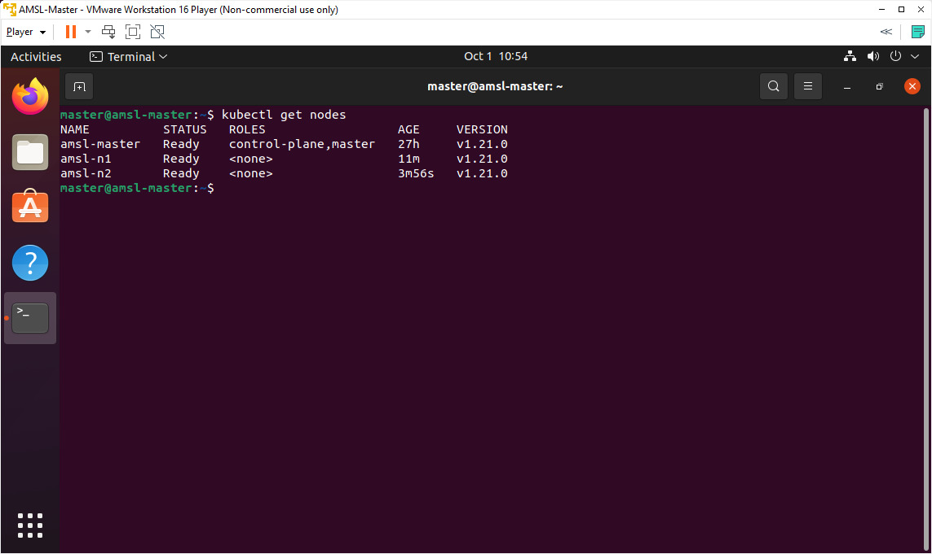

***Note: Above output might say Not Ready until the networking pod is created on the new node.

From the above output we can see both nodes are connected on the cluster and status is ready.

1. On the Control Plane Node, watch for the calico pod and the kube-proxy to change to Running on the newly added nodes by below command.

kubectl get pods --all-namespaces --watch

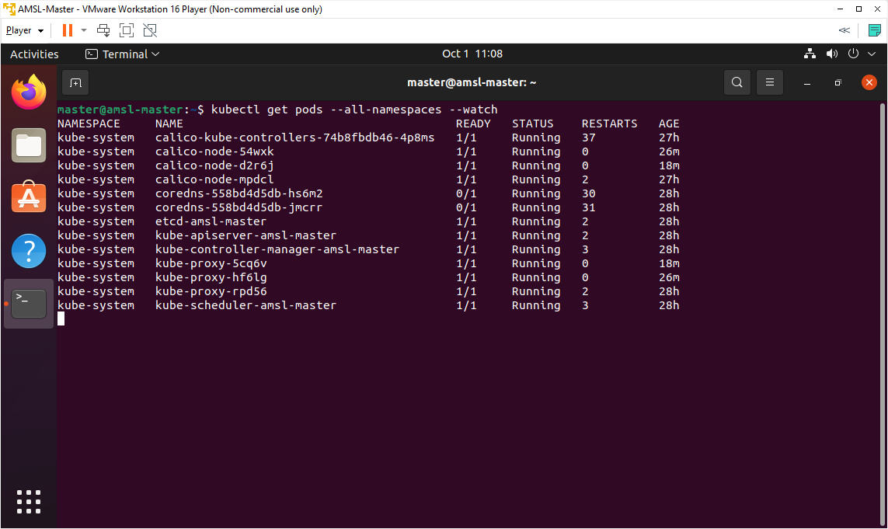

On the above output is showing all system pods are running.

# Applying different Commands

Now we are going to try with different commands to understand in depth.

1. You can use below command for listing and inspecting the cluster and this command is helpful for knowing which cluster is your current context.

kubectl cluster-info

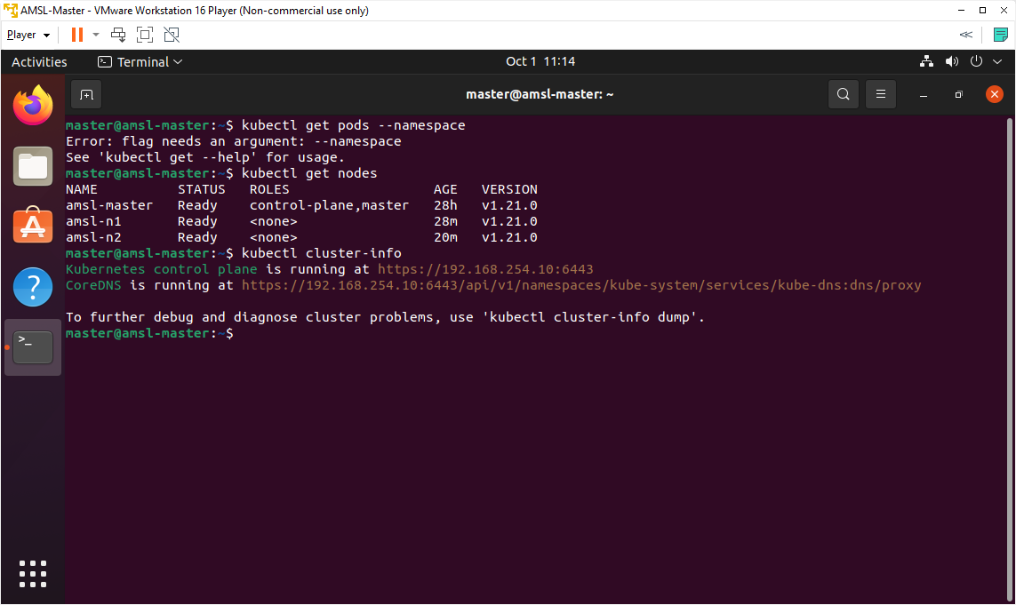

1. You can add an output modifier to get to *get* more information about a resource.

kubectl get nodes -o wide

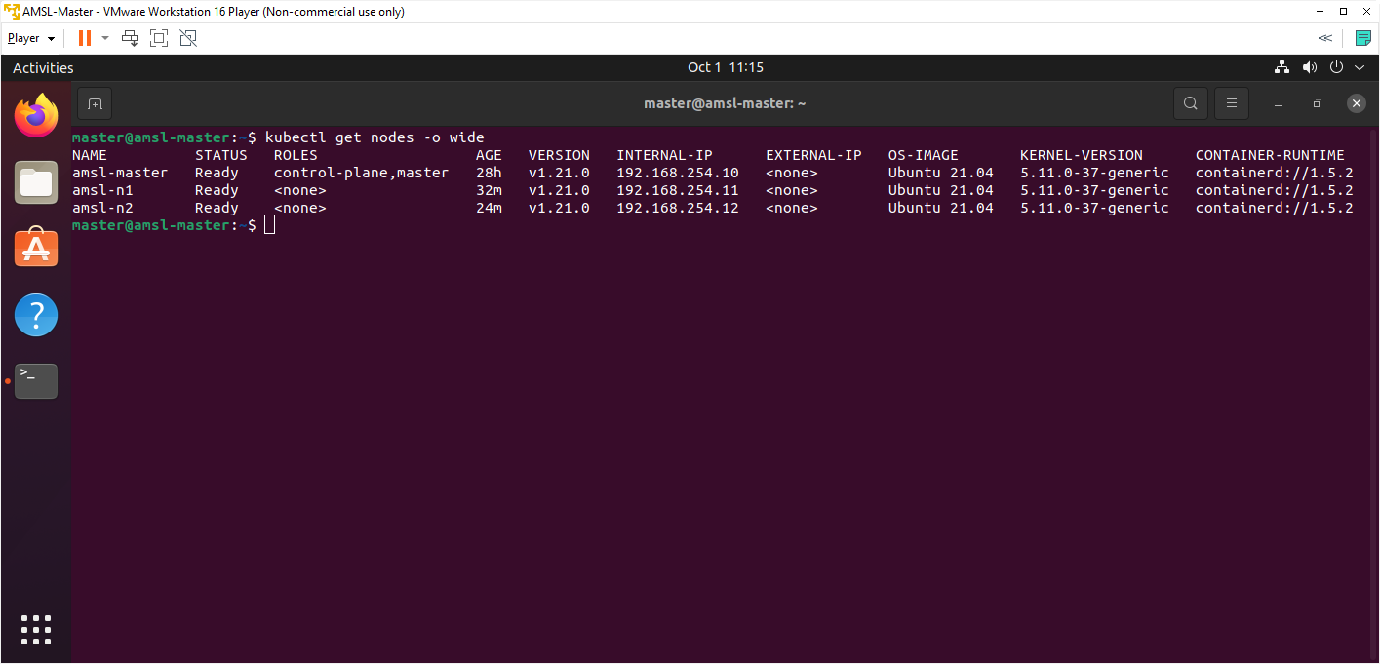

1. Let's get a list of system pods with extra information. A namespace is a way to group resources together.

kubectl get pods --namespace kube-system -o wide

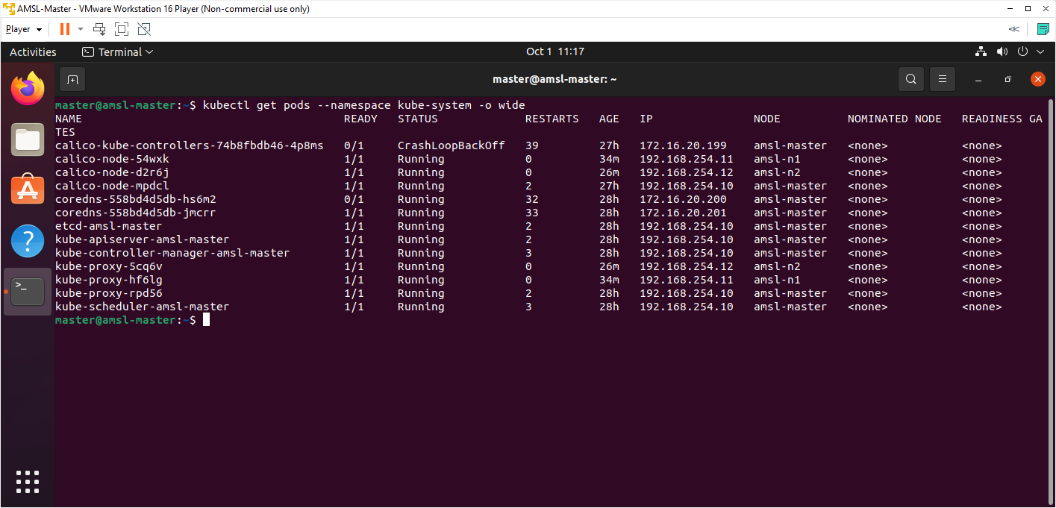

1. Now let's get a list of everything that's running in all namespaces. In addition to pods, we see services, daemon sets, deployments and replica sets.

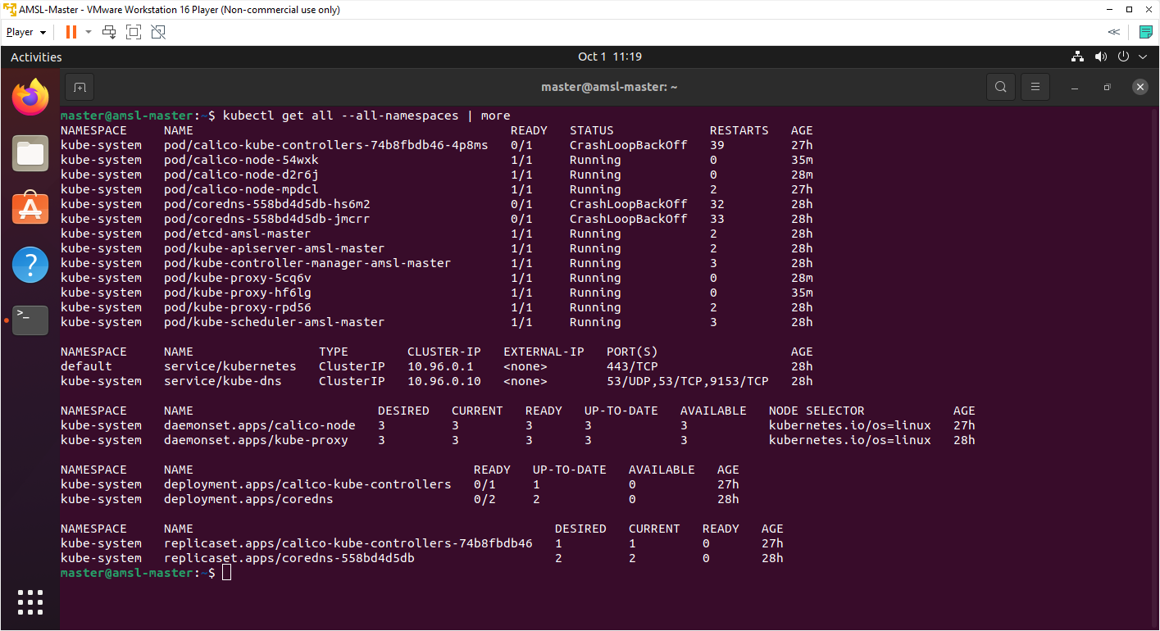

1. Let's look at the headers in each column. Name, Alias/shortnames, API Version

kubectl api-resources | more

1. Let's take a closer look at our nodes using Describe

kubectl describe nodes [nodeName] | more

# Deploying the Dashboard UI

Dashboard is a web-based Kubernetes user interface which we can use to deploy containerized applications to a Kubernetes cluster, troubleshoot the containerized application, and manage the cluster resources. Dashboard also provides information on the state of Kubernetes resources in the cluster and on any errors that may have occurred.

1. The Dashboard UI is not deployed by default. To deploy it, run the following command.

kubectl apply -f https://raw.githubusercontent.com/kubernetes/dashboard/v2.3.1/aio/deploy/recommended.yaml

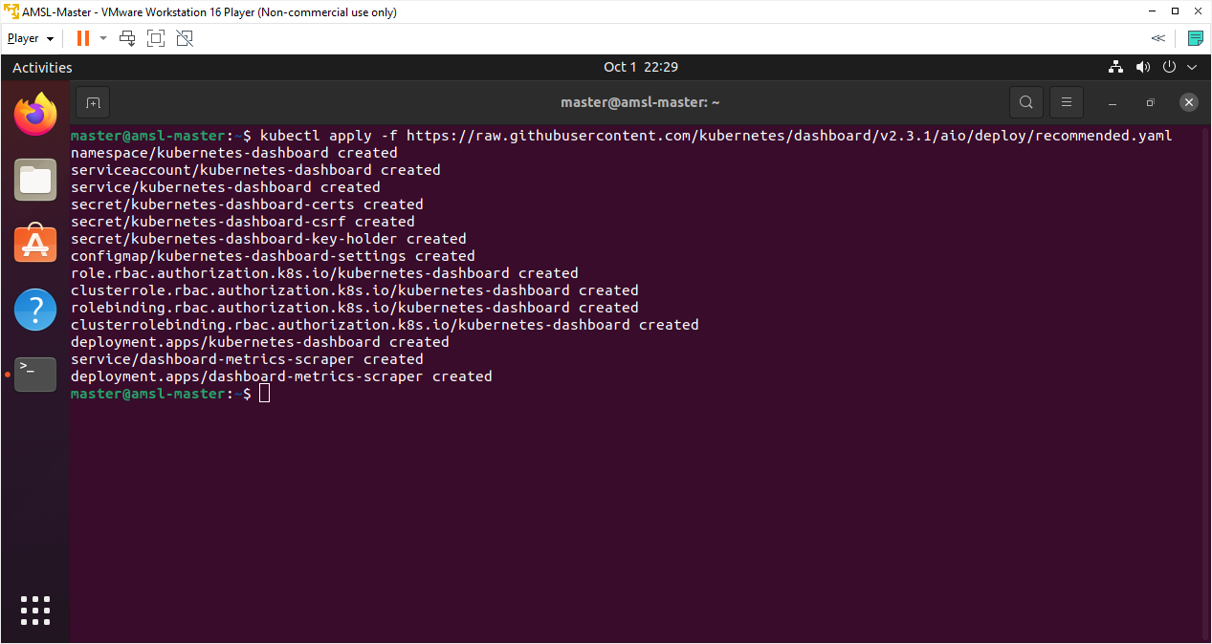

1. Let’s check the namespaces with below command.

kubectl get ns

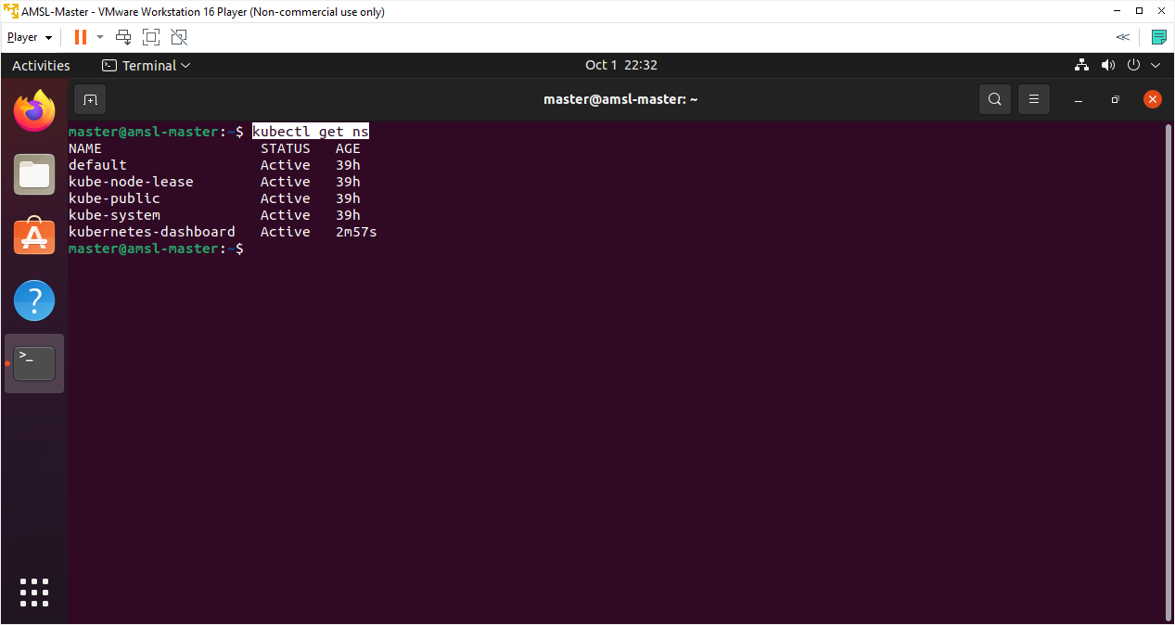

On the above output, we can see a new namespaces on the list.

1. Now is the time to check if any pods are running on newly created namespaces with below command.

kubectl -n kubernetes-dashboard get pods -o wide

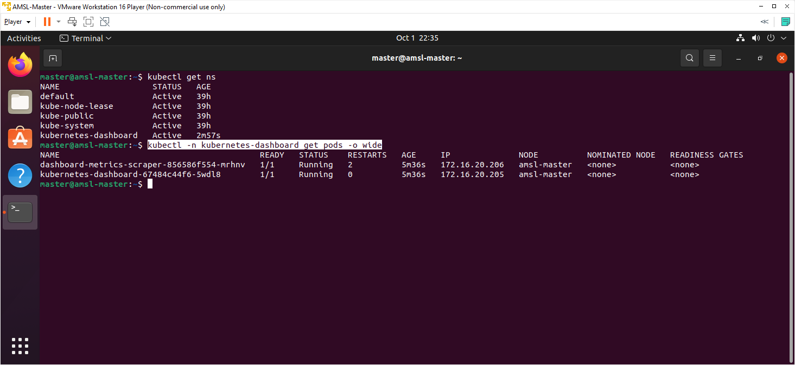

We can see that two namespaces are running within above namespace.

1. Check the service type with below command.

kubectl -n kubernetes-dashboard get svc

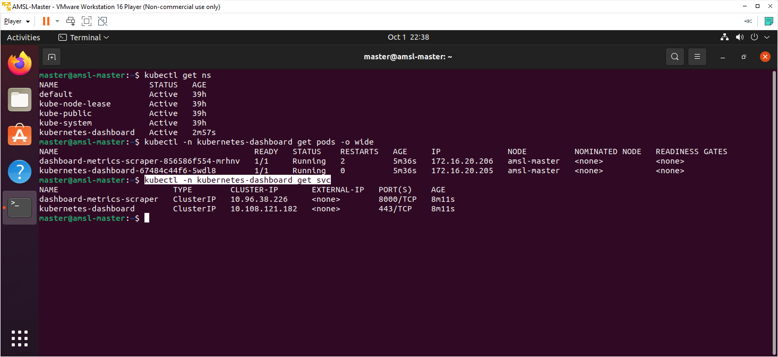

Default service type is ClusterIP and it cannot be access from outside the cluster. We don’t need to modify Service file because we are not going to expose the cluster to the outside world.

1. Create a file and name the file dashboard-adminuser.yaml with below command.

cat > dashboard-adminuser.yaml

1. Copy and paste following code on dashboard-adminuser.yaml file.

apiVersion: v1

kind: Namespace

metadata:

name: kubernetes-dashboard

---

apiVersion: v1

kind: ServiceAccount

metadata:

name: admin-user

namespace: kubernetes-dashboard

---

apiVersion: rbac.authorization.k8s.io/v1

kind: ClusterRoleBinding

metadata:

name: admin-user

roleRef:

apiGroup: rbac.authorization.k8s.io

kind: ClusterRole

name: cluster-admin

subjects:

- kind: ServiceAccount

name: admin-user

namespace: kubernetes-dashboard

1. As we are using new cluster binding so we need to delete the existing Cluster Binding section from kubernetes-dashboard file, otherwise an error will return. Use below command to delete.

kubectl delete clusterrolebinding kubernetes-dashboard

1. Now we are going to execute newly created file with below command.

kubectl apply -f dashboard-adminuser.yaml

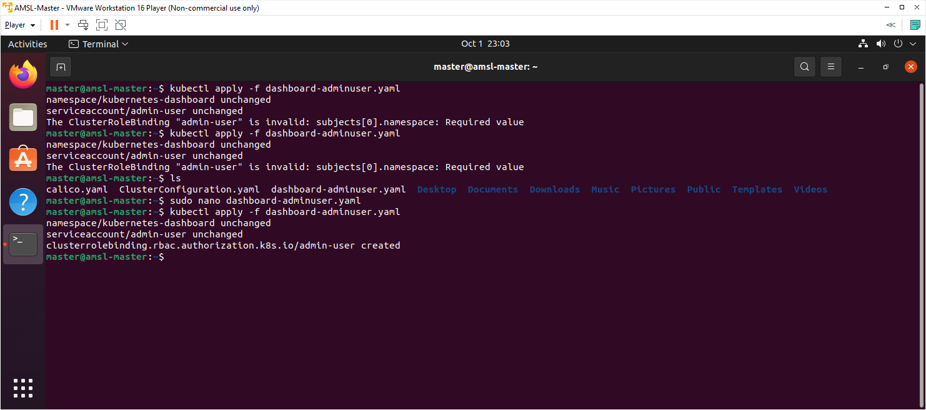

1. Now we need to find token we can use to log in. Execute following command:

kubectl -n kubernetes-dashboard get secret $(kubectl -n kubernetes-dashboard get sa/admin-user -o jsonpath="{.secrets[0].name}") -o go-template="{{.data.token | base64decode}}"

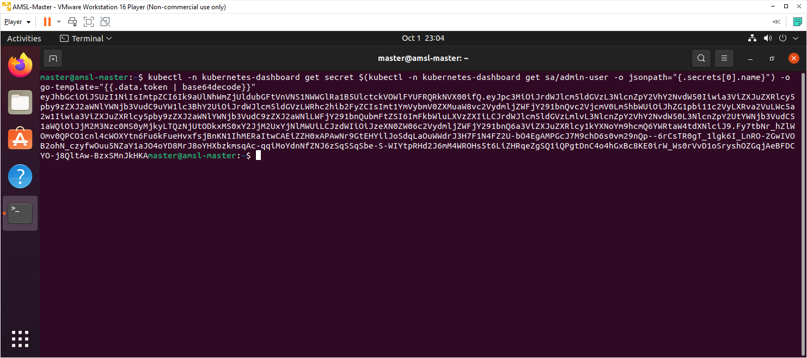

From the above output we can see a new token has been generated, we can copy the above output token to login into dashboard.

1. Use following command to enable the access to the Dashboard using the kubectl command-line tool.

kubectl proxy

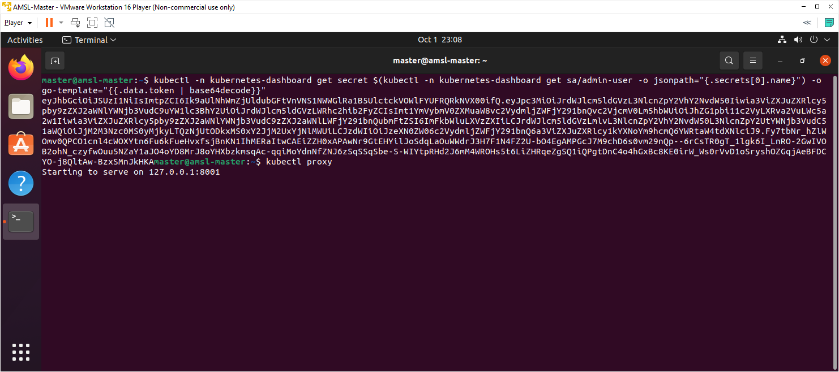

1. Use below URL to access the dashboard.

<http://localhost:8001/api/v1/namespaces/kubernetes-dashboard/services/https:kubernetes-dashboard:/proxy/>

1. Use above created token and click sign in button.

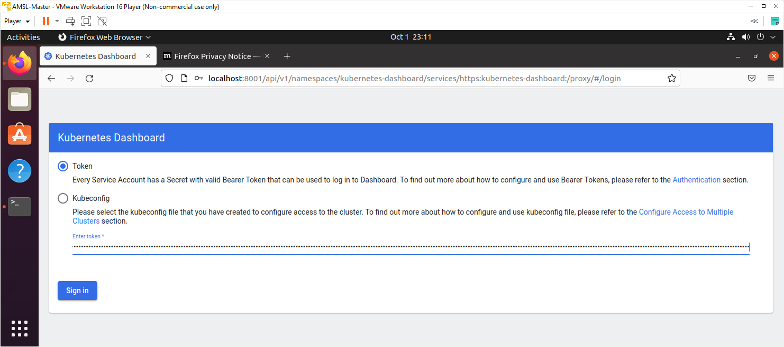

Workload section will show empty because we have not deployed any containerized pod yet. You can click cluster tab on left pane and will find list of cluster roles, Namespaces, Nodes and Storage Classes. You will find two nodes in the list of Nodes.

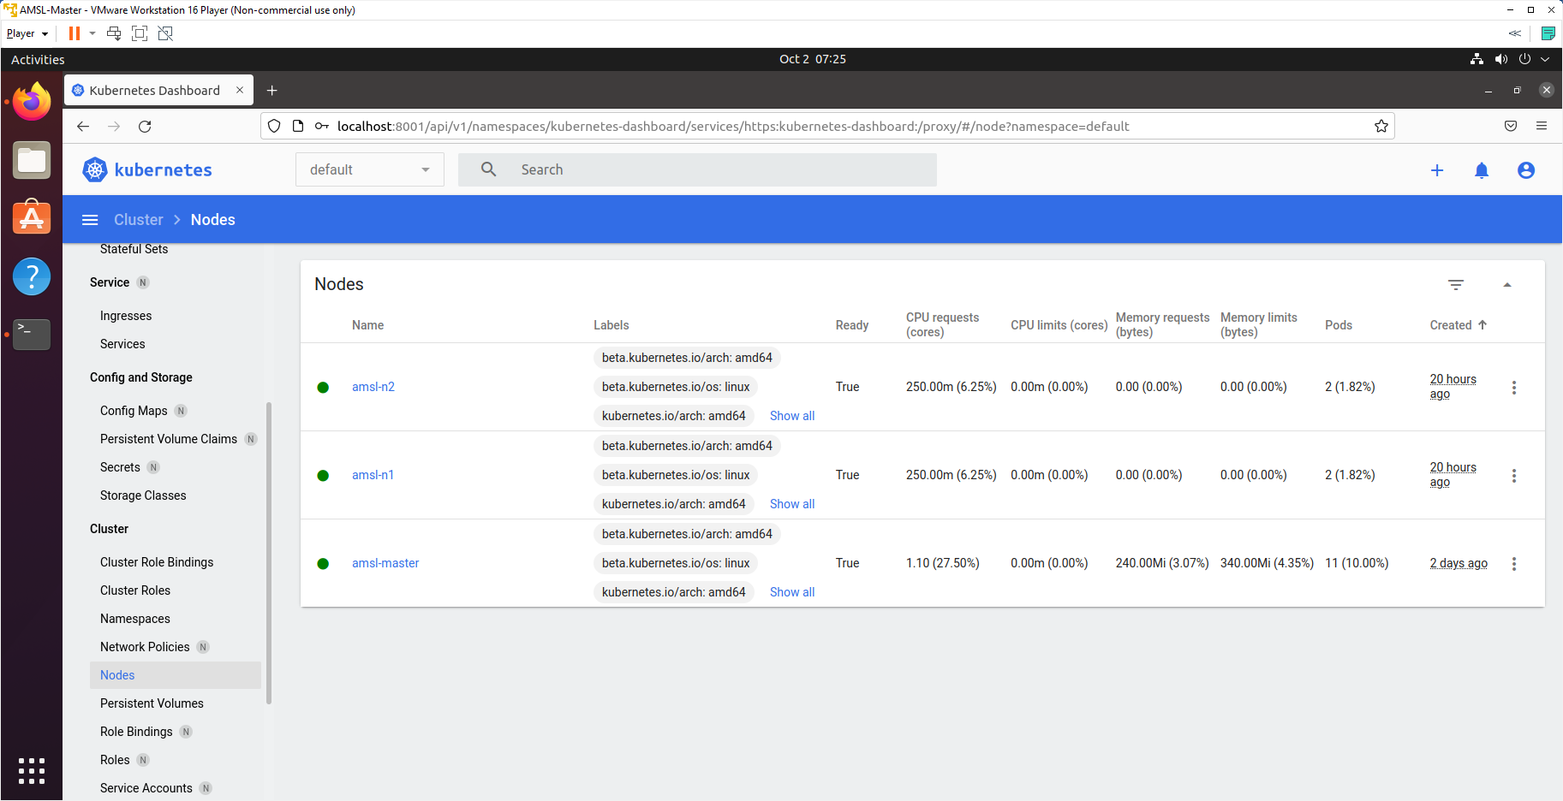

# Deploy a Pod to the Target Node

Now we are going to deploy a containerized pod to target node. Before we assign the pod we are going to set a label for node.

1. Check current label of nodes with below command.

kubectl get nodes --show-labels

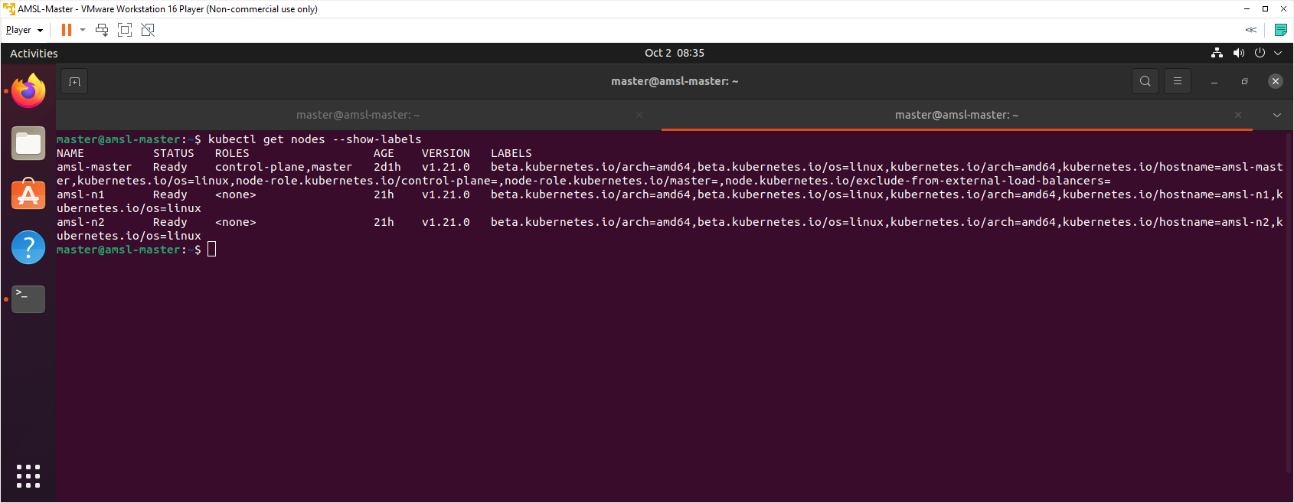

1. Now we are going to set custom label for nodes. I have decided to set the label for amsl-n1 will be env=dev and amsl-n2 will be env=prod. Use below commands to set labels for nodes.

kubectl label nodes amsl-n1 env=dev

kubectl label nodes amsl-n2 env=prod

1. We can recheck label name again with below command.

kubectl get nodes --show-labels

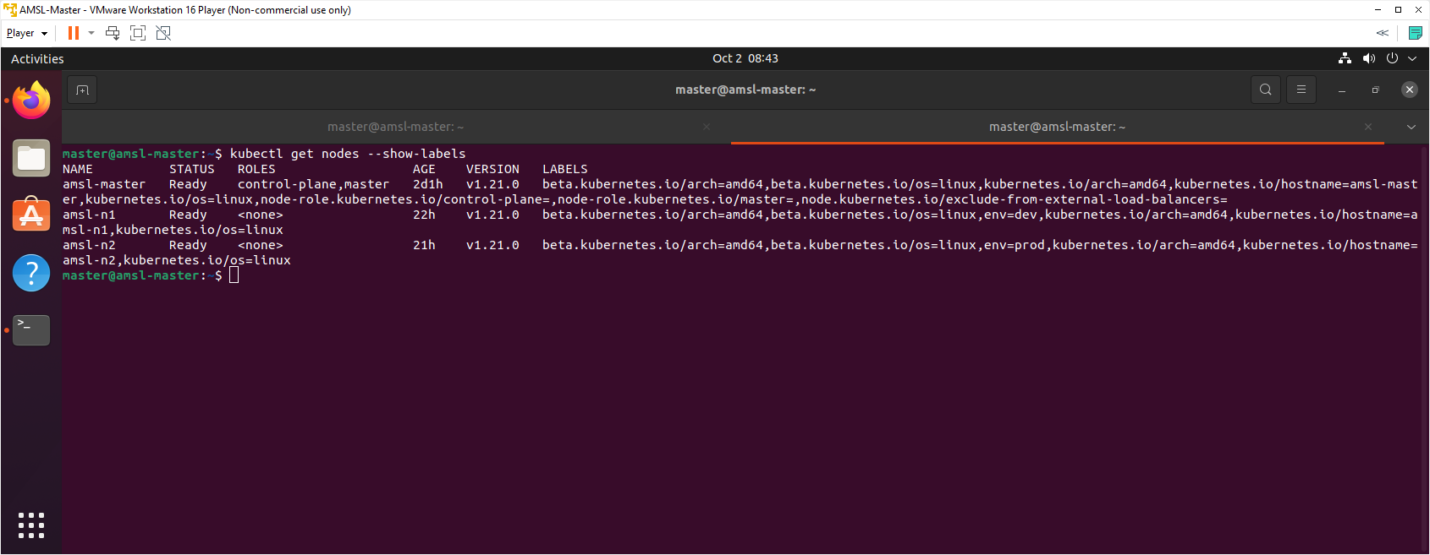

## Deploying Resources Declaratively

Now we are going to deploy pod declaratively with YAML file.

1. We are going to use dry-run=client to create a yaml manifest file for deployment with a container image. We could write the yaml by hand, but we can use dry-run=client to build it for us. Write below command to generate yaml manifest file.

**kubectl create deployment hello-world \**

**--image=gcr.io/google-samples/hello-app:1.0 \**

**--dry-run=client -o yaml | more**

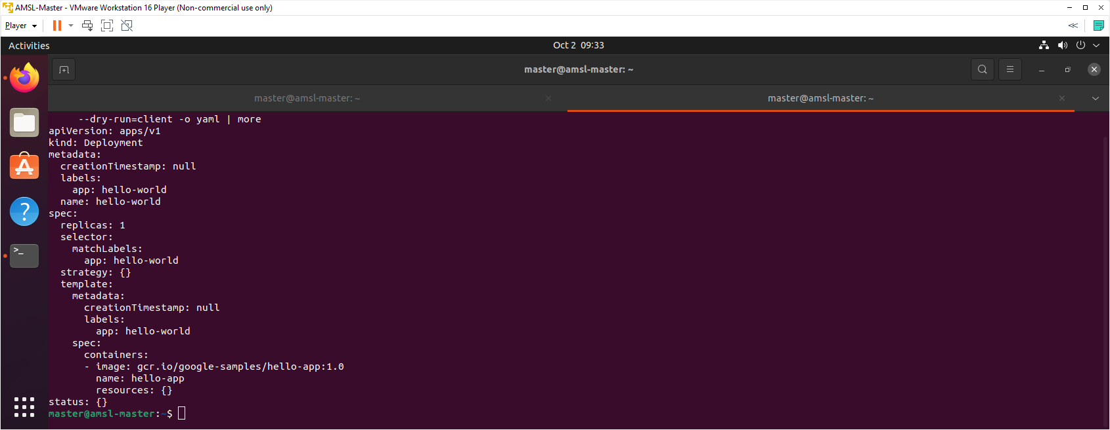

1. Let's write this deployment yaml out to file. We are now redirecting previously generated output to deployment.yaml file.

**kubectl create deployment hello-world \**

**--image=gcr.io/google-samples/hello-app:1.0 \**

**--dry-run=client -o yaml > deployment.yaml**

1. Edit deployment.yaml file to set a node label. Use below command to edit the file.

sudo nano deployment.yaml

1. Update the file with below text.

apiVersion: apps/v1

kind: Deployment

metadata:

creationTimestamp: null

labels:

app: hello-world

name: hello-world

spec:

replicas: 1

selector:

matchLabels:

app: hello-world

strategy: {}

template:

metadata:

creationTimestamp: null

labels:

app: hello-world

spec:

containers:

- image: gcr.io/google-samples/hello-app:1.0

name: hello-app

resources: {}

nodeSelector:

env: dev

status: {}

1. Use below command to execute the deployment.yaml manifest file.

kubectl apply -f deployment.yaml

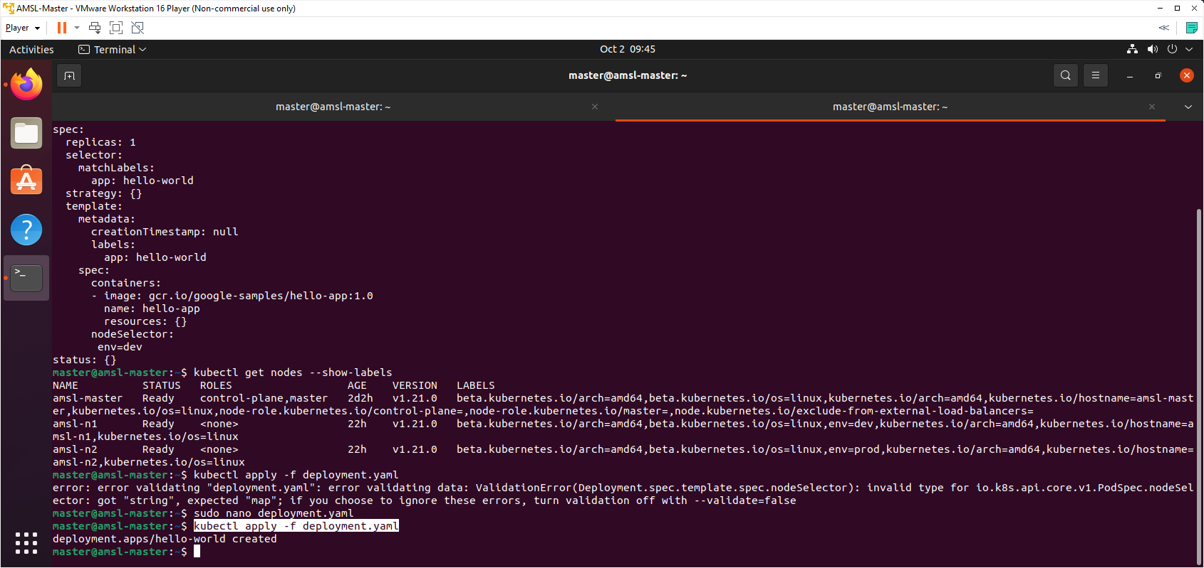

1. Now generate the yaml for the service with below command.

**kubectl expose deployment hello-world \**

**--port=80 --target-port=8080 \**

**--dry-run=client -o yaml | more**

1. Write the service yaml manifest to a file.

**kubectl expose deployment hello-world \**

**--port=80 --target-port=8080 \**

**--dry-run=client -o yaml > service.yaml**

1. Use below command to execute the service yaml file declaratively.

kubectl apply -f service.yaml

1. Check out our current state, Deployment, ReplicaSet, Pod and a Service.

kubectl get all -o wide

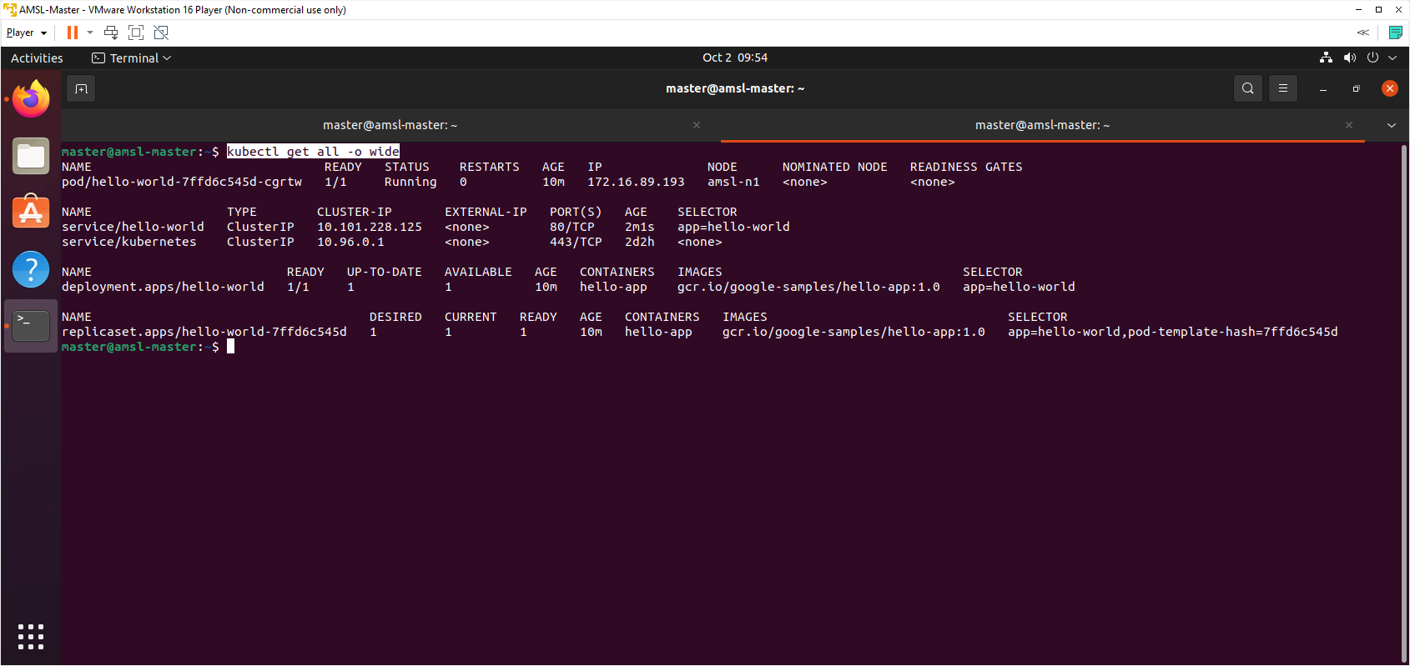

We can see recent deployed pod and service from the above output and running without error. Hello-world pod has been deployed to amsl-n1 node as per configuration of label.

1. Kubectl create deployment we executed, it created a deployment for us. Let's look more closely at that deployment.

kubectl get deployment hello-world

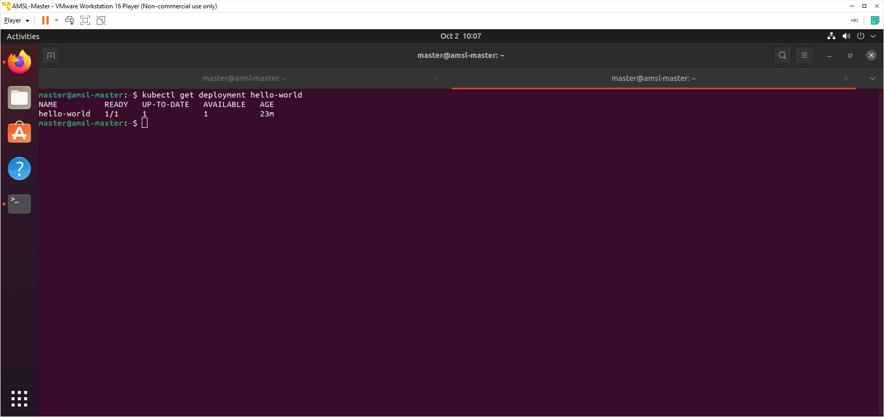

1. Deployments are made of ReplicaSets and ReplicaSets create Pods!

kubectl get replicaset

kubectl get pods

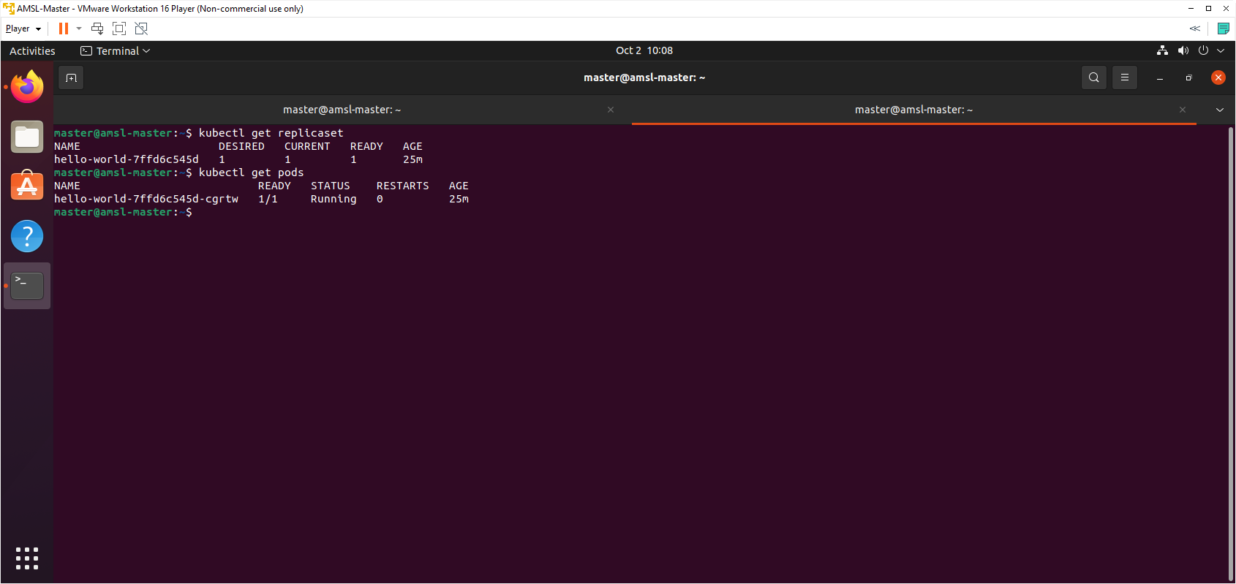

1. We can also get that information from using describe.

kubectl describe service hello-world

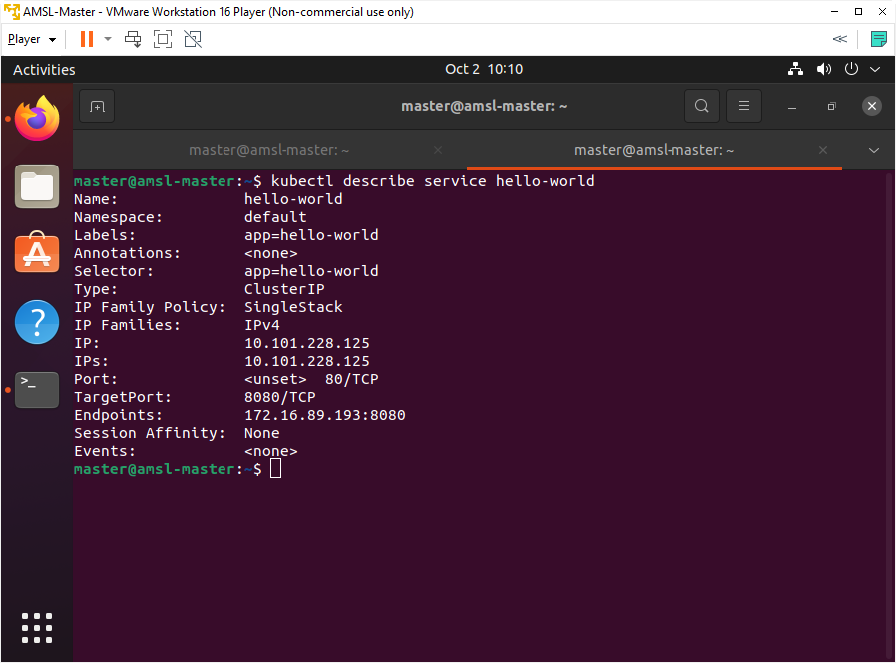

1. Endpoints are IP:Port pairs for each of Pods that that are a member of the Service. Access the Service inside the cluster.

curl http://10.101.228.125

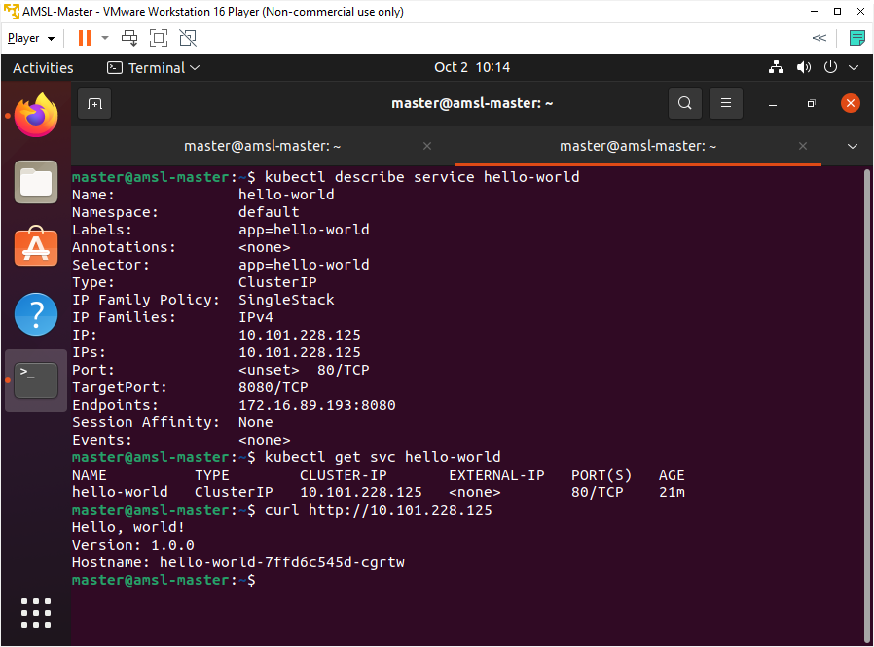

Please use the IP address generated in your system.

1. Access a single pod's application directly with below command, useful for troubleshooting.

kubectl get endpoints hello-world

curl http://172.16.89.193:8080

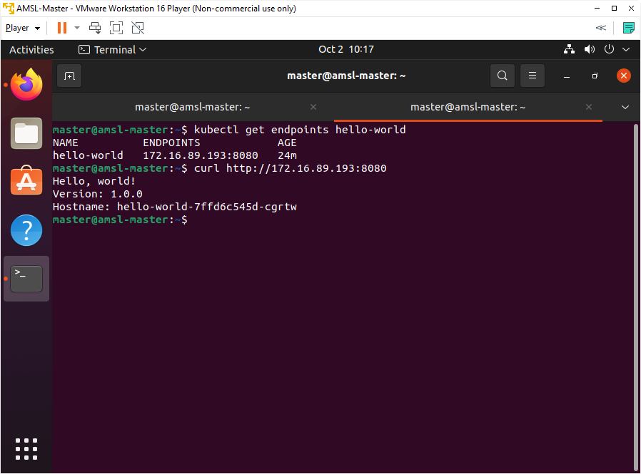

## Verify with Dashboard UI

1. Log back to Dashboard UI to verify the current state.

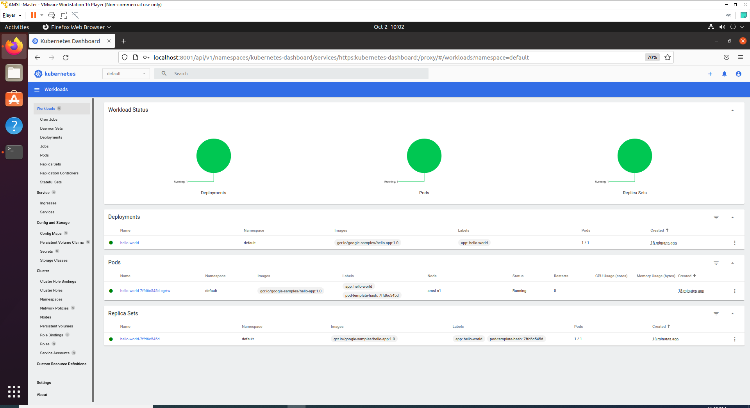

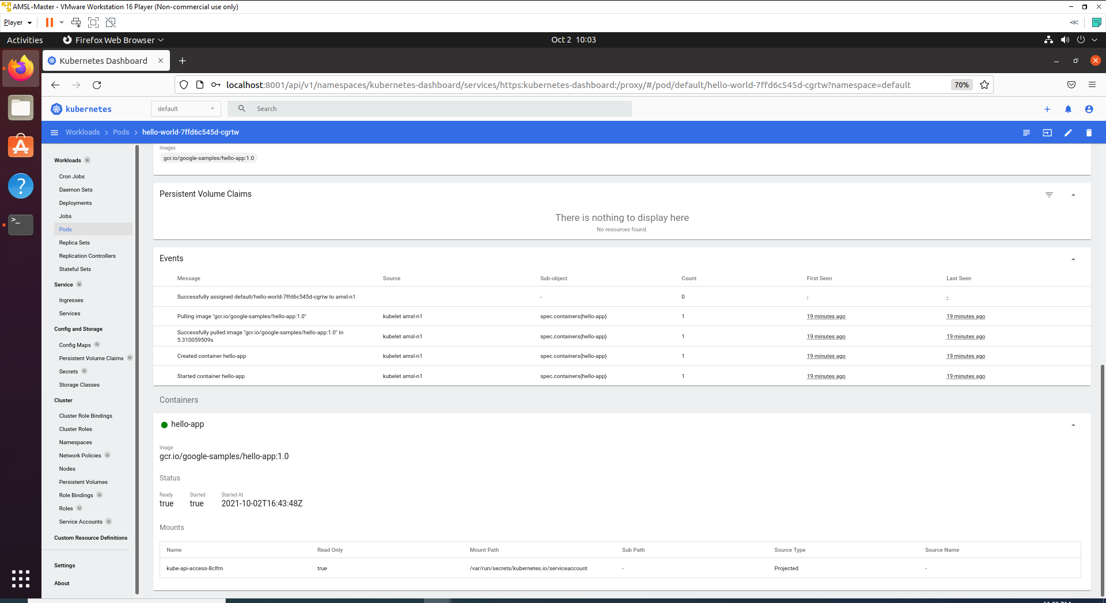

Everything running healthy and pod has generated Container with image.

# References

<https://kubernetes.io/docs/reference/>

<https://minikube.sigs.k8s.io/docs/tutorials/multi_node/>

<https://kubesphere.io/docs/installing-on-linux/introduction/multioverview/>

<https://betterprogramming.pub/build-your-own-multi-node-kubernetes-cluster-with-monitoring-346a7e2ef6e2>

<https://acloudguru.com/blog/engineering/building-a-three-node-kubernetes-cluster-quick-guide>

<https://www.stackrox.io/blog/kubernetes-networking-demystified/>

<https://codebots.com/docs/ubuntu-18-04-virtual-machine-setup>

<https://kubernetesclustersetup.blogspot.com/>

<https://www.brianlinkletter.com/2016/07/how-to-use-virtualbox-to-emulate-a-network/>

<https://kubernetes.io/docs/reference/generated/kubectl/kubectl-commands>

<https://cloud.google.com/kubernetes-engine/docs/concepts/using-containerd>

<https://kubernetes.io/docs/tasks/configure-pod-container/assign-pods-nodes/>

<https://kubernetes.io/docs/tasks/access-application-cluster/web-ui-dashboard/>

<https://www.educba.com/kubernetes-selector/>

<https://www.cloudsavvyit.com/10075/what-is-containerd-and-how-does-it-relate-to-docker-and-kubernetes/>

<https://www.tutorialworks.com/difference-docker-containerd-runc-crio-oci/>

<https://containerd.io/>